Software Requirements Specification
for
Group Scheduling Application
Version 2.2
Prepared by SCEE Group 2 — Caleb Soon Gengrui, Gajulapalli Anish Reddy, Gao Ziru, Goh Chiew Yik, Tang Haoyang, Wang HuiXuan
Nanyang Technological University — SC2006 Software Engineering, Lab 2
24 October 2026
Table of Contents ii
Revision History ii
1. Introduction 1
1.1 Purpose 1
1.2 Document Conventions 1
1.3 Intended Audience and Reading Suggestions 1
1.4 Product Scope 2
1.5 References 3
2. Overall Description 3
2.1 Product Perspective 3
2.2 Product Functions 4
2.3 User Classes and Characteristics 4
2.4 Operating Environment 5
2.5 Design and Implementation Constraints 5
2.6 User Documentation 6
2.7 Assumptions and Dependencies 6
3. External Interface Requirements 7
3.1 User Interfaces 7
3.2 Hardware Interfaces 9
3.3 Software Interfaces 9
3.4 Communications Interfaces 10
4. System Features 10
4.1 Session Startup 10
4.2 Availability Collection 12
4.3 Candidate Generation 15
4.4 Feasibility and Scoring 16
4.5 Results and Confirmation 18
5. Other Nonfunctional Requirements 20
5.1 Performance Requirements 20
5.2 Safety Requirements 20
5.3 Security Requirements 20
5.4 Software Quality Attributes 21
5.5 Business Rules 22
6. Other Requirements 23
Appendix A: Glossary 24
Appendix B: Analysis Models 27
Appendix C: To Be Determined List 36
Table of Contents

Appendix D: Data Dictionary....................................................................................................42
Appendix E: System Architecture.........................................................................................51

Revision History
Name | Date | Reason For Changes | Version
SCEE Group 2 | 28 Aug 2026 | Initial draft — Football Venue & Timeslot Optimizer. | 0.1
SCEE Group 2 | 3 Sep 2026 | Extended Data Dictionary added: entity definitions and privacy rules. | 1.1
SCEE Group 2 | 9 Sep 2026 | Scope generalised from football to any activity type; requirements atomised; Open Questions consolidated. | 1.4
SCEE Group 2 | 21 Sep 2026 | Content reorganised; no requirement removed. Feature priorities assigned. Added mandatory Google Account sign-in for Organisers and Participants, replacing the no-account design (resolves TBD-6, TBD-10 and TBD-11). | 2.0
SCEE Group 2 | 24 Oct 2026 | Internal inconsistencies corrected: Venue shortlist timing fixed to Generate Recommendations (resolves TBD-14); NFR-14 calendar scope reworded and FR-B9.1 added (resolves TBD-12); TBD-6 resolution corrected; booking-link step removed from UC-12; NFR-1 criterion, result-display fields, withdrawal behaviour, figure numbering and cross-references aligned. | 2.1
SCEE Group 2 | 24 Oct 2026 | Appendix E (System Architecture, Figure 5, Table E-1) added; references R9 to R12 added; dialog map referenced from Section 3.1; cross-references in Sections 1.3 and 2.1 updated. | 2.2

Introduction

Purpose
This Software Requirements Specification describes the Group Scheduling Application (formerly the Group Football Venue & Timeslot Optimizer), a mobile-responsive web application that recommends both a time and a venue for a group activity.
This document covers the complete system for its initial release: session creation and management, participant availability collection, candidate timeslot and venue generation, feasibility filtering and scoring, and the organiser’s confirmation of a final plan. It also covers the system’s interfaces to four external data providers — OneMap, data.gov.sg, LTA DataMall and the Google Calendar API.
Venue booking, payment and booking-outcome tracking lie outside the boundary of the system described here and are not specified in this document. Items deferred beyond the initial release are listed in Section 1.4.

Document Conventions
Requirement statements. Every requirement in this document is written as a single, verifiable statement in active voice with a named actor, using “must” rather than “may” or “should”. Compound behaviours are split into separate atomic requirements rather than combined in one statement.
Identifiers. Functional requirements are identified as FR-xN, where x is the feature module (A to E, corresponding to Sections 4.1 to 4.5) and N is a sequence number within that module — for example, FR-B4. Non-functional requirements are identified as NFR-N in a single sequence across all features. A decimal suffix (FR-A1.1, FR-B3.1, FR-D9.1) marks a sub-requirement decomposed from the requirement directly above it, covering either an edge case or a data-validation constraint on a field the parent requirement introduces. Sub-requirement rows are shaded tan in the functional-requirement tables of Section 4.
Defined terms. Terms carrying a specific meaning in this document — Session, Participant, Organiser, Venue, Combination, Candidate Timeslot and others — are capitalised on every use and are defined once in Appendix A. They are not redefined in individual requirement statements.
Priority. Priority is stated once per feature in Section 4.x.1 and is inherited by every functional requirement within that feature; individual requirement statements do not carry their own priority. Where a requirement within a feature warrants a different priority, this is stated explicitly in that requirement’s row.
Unresolved items. Points that cannot be resolved without the client are marked TBD and cross-referenced to the numbered entry in Appendix C rather than resolved by assumption. Inline cross-references between requirement IDs (for example, “see FR-C2”) indicate traceability between dependent requirements.

Intended Audience and Reading Suggestions
Intended audience. This document is written for four types of reader:
• Developers implementing the system, who require the functional requirements in Section 4 and the interface definitions in Section 3 to be unambiguous and verifiable.
• Designers producing the architecture, class and sequence models in the following design phase, who need the data definitions in Appendix A and the analysis models in Appendix B as the basis for their work.
• Testers deriving test cases, who need each requirement to be individually testable and each non-functional requirement in Section 5 to carry a measurable acceptance criterion.
• The client and course assessors, who need to confirm that the specified system matches the stated need, and to see which points remain open rather than silently assumed.
Document organisation. Section 1 introduces the product, the conventions used and the document’s scope. Section 2 gives the overall description: product context, a summary of major functions, the user classes, the operating environment, design constraints and the assumptions the requirements rest on. Section 3 specifies the external interfaces — user, hardware, software and communications. Section 4 is the core of the document: the functional requirements, organised into five features that follow the system’s operating sequence from session creation through to confirmation, each with a description and priority, its stimulus/response sequences, and its itemised requirements. Section 5 states the non-functional requirements under performance, safety, security, quality attributes and business rules. Section 6 covers remaining requirements not classified elsewhere. Appendix A is the glossary, Appendix B holds the use-case and data models, Appendix C lists every unresolved TBD item for tracking to closure, Appendix D is the data dictionary, and Appendix E describes the system architecture.
Suggested reading sequence. All readers should begin with Sections 1 and 2 for the product’s purpose, scope and context, and should refer to Appendix A whenever a capitalised defined term is encountered.
• Developers should then read Section 3, followed by Section 4 in full and Section 5, referring to Appendix B for the use-case diagram and data relationships.
• Designers should proceed from Section 2 to Appendix B, then to Section 4 for the behaviour each model must support, then to Sections 5.4 and 6 for the constraints that shape the architecture, and then to Appendix E for the architecture itself.
• Testers should read Section 4 alongside Section 5, using the acceptance criteria in Section 5 and the stimulus/response sequences in Section 4.x.2 as the basis for test cases.
• The client should read Sections 1 and 2, then Section 4.x.1 for the feature descriptions and priorities, then Appendix C, which lists the questions requiring a client decision.
Appendix C should be read by every reader before this document is taken into design, since unresolved items there affect requirements across Sections 4 and 5.

Product Scope
The Group Scheduling Application determines both when and where a group should meet for a shared activity. The System jointly optimises Participant availability against real multimodal travel time, rather than choosing a time and a venue as two separate, sequential decisions.
The System ingests each Participant’s starting location and availability for a Session, generates candidate Timeslot × Venue Combinations across the Venues supporting that Session’s activity type (spanning Sports Facilities, Parks and Malls), and computes a ranked, Organiser-tunable Combined Score built from attendance and travel time. It recommends the best Combination for the group to confirm.
Objective and benefit. The project benefits casual groups who currently coordinate manually over chat threads, replacing ad hoc guesswork with a defensible, data-driven recommendation. The project is considered complete when an Organiser can create a Session, Participants can respond via a shared invitation link, and the System can present a ranked, Organiser-tunable set of venue-and-Timeslot Combinations for the Organiser to confirm.
Out of scope for the initial release:
• Any form of booking assistance: booking-channel links, live venue-availability lookup, in-app payment or transaction processing, and booking-outcome tracking. Booking the chosen Venue is left entirely to the group, outside the application.
• Weather forecasts and venue shelter status as a scoring or display factor.
• Support for calendar providers beyond Google Calendar.
• Push, SMS and email notification of status changes; status is surfaced only by visiting the Session’s shared page (Section 2.5).

References
Ref. | Title / Source | Use in this document
R1 | OneMap API — Singapore Land Authority national mapping platform. https://www.onemap.gov.sg/apidocs/ | Geocoding of Participant starting locations, routing for travel-time estimates, and Venue geolocation (FR-B3, FR-D2).
R2 | data.gov.sg — Singapore whole-of-government open data portal. https://data.gov.sg/ | Sports-facility and park Venue datasets (FR-C3).
R3 | LTA DataMall — Land Transport Authority open data portal. https://datamall.lta.gov.sg/ | Public-transport travel times, pending confirmation against OneMap coverage (FR-D2, TBD-3).
R4 | Google Calendar API v3 — Google LLC. https://developers.google.com/calendar | Importing Participant free/busy data and writing tentative and confirmed Session events (FR-B8 to FR-B10, FR-E6).
R5 | Personal Data Protection Act 2012 (Act 26 of 2012), Singapore Statutes Online. | Governs collection, use and disclosure of Participant personal data (Section 5.3).
R6 | K. Wiegers, Software Requirements Specification template. http://www.frontiernet.net/~kwiegers/process_assets/srs_template.doc | Structure and section headings of this document.
R7 | SC2006 / CE2006 / CZ2006 Requirements Elicitation lecture notes and Week 3 tutorial, NTU. | Requirement-writing conventions described in Section 1.2.
R8 | Group Scheduling Application — SRS v1.4 and Extended Data Dictionary v1.1, SCEE Group 2, 9 September 2026. | Predecessor document; all content in this SRS is carried forward from it.
R9 | B. Bruegge and A. H. Dutoit, Object-Oriented Software Engineering Using UML, Patterns, and Java, 3rd ed., Prentice Hall, 2010, Chapter 7. | System design issues addressed in Appendix E.3.
R10 | Group Scheduling Application — Unified Design Class Diagram (Group_Scheduling_Unified_Class_Diagram 5.drawio), SCEE Group 2. | Class names used in Appendix E.
R11 | Dialog Map — Group Scheduling App (Figma). https://www.figma.com/board/tfof2o0IqKWTRLi1SKxUyS/Dialog-Map---Group-Scheduling-App | Navigation between the screens in Section 3.1.
R12 | Lab 3 AI Project Initialisation Report (revised), SCEE Group 2, 3 October 2026. | Technology stack and the Google Calendar scope note in Appendix E.4.

All data sources are authorised, documented public or OAuth-scoped APIs. No scraping of undocumented endpoints is in scope (NFR-17).

Overall Description

Product Perspective
The Group Scheduling Application is a new, self-contained product. It is not a replacement for, or a component of, an existing system, and it is not a member of an existing product family. It originated as a football-specific venue and timeslot optimiser and has been generalised to any activity category and activity type an Organiser selects at Session creation.
The product is delivered as a three-tier web application: a mobile-responsive browser client, a backend application containing the candidate-generation and scoring engine, and a durable SQL-compliant database accessible only to the backend (NFR-9, NFR-16). The backend is the sole consumer of the four external data providers; no client-side code calls an external API or the database directly.
The System is positioned between the group’s existing coordination channel — typically a chat thread, where the invitation link is shared — and the Venue’s own booking channel, where the group completes the booking itself. The System replaces the decision-making step between the two; it does not replace either of them.
The architecture of the client, backend, database and external providers is described in Appendix E (Figure 5).

Product Functions
The major functions the product must perform, grouped as the five features specified in Section 4:
• Session Startup (Section 4.1) — create a Session with an activity category, activity type, date range and duration; generate a shareable invitation link; set a response deadline and a Minimum-Attendee Threshold; cancel a Session before confirmation.
• Availability Collection (Section 4.2) — accept each Participant’s availability on a date-range grid, starting location and preferred transport mode via the invitation link; geocode the location; optionally prefill availability from a connected Google Calendar; allow responses to be modified or withdrawn before the deadline; show the Organiser who has responded.
• Candidate Generation (Section 4.3) — enumerate every Candidate Timeslot in the Session’s date range, count Participant availability per Timeslot, filter the Venue catalogue to Venues supporting the activity type, and shortlist the Venues nearest the Participant centroid.
• Feasibility and Scoring (Section 4.4) — exclude Combinations failing attendance, journey-time, Venue group-size or advance-booking constraints; retrieve routing-based travel durations; compute attendance and travel scores under the Organiser’s chosen Travel Objective and weighting, and produce a ranked Combined Score.
• Results and Confirmation (Section 4.5) — display the top-ranked Combinations with per-Participant travel times and attendance lists; allow the Organiser to confirm a final Combination; publish the outcome on the shared Session page and write confirmed events to attending Participants’ calendars.
The use-case diagram in Appendix B shows how these functions relate and which actor initiates each.
Figures 1 and 2 provide an overview of the main entity, boundary, and control classes that support the product functions described above. The class diagram is divided into two parts for readability: the first focuses on session and participant management, while the second covers venue matching, recommendation generation, and the related boundary and control classes.

Figure 1. Class Diagram Part 1 — Session and Participant Management

Figure 2. Class Diagram Part 2 — Venue Matching, Recommendation, Boundary and Control Classes

User Classes and Characteristics
Two human user classes use the product. Both are favoured equally; neither is secondary, since a Session cannot complete without both.
User class | Characteristics | Functions used | Importance
Organiser | The Participant who created the Session and holds administrative rights over it. No technical expertise assumed. Uses the product occasionally, once per event organised. Motivated to reach a decision quickly and to justify it to the group. | All functions. Exclusively: setting Session parameters (FR-A1 to FR-A4), selecting the Travel Objective and weighting (FR-D6, FR-D9), confirming the final Combination (FR-E4) and cancelling the Session (FR-A5). | Primary
Participant | A person invited to a Session via its invitation link, who signs in with a Google Account on first use. No prior training and no technical expertise assumed beyond that one-time sign-in. May use the product only once. Typically responds on a mobile device, quickly, in the middle of a chat conversation. Privacy-sensitive: supplies a home address to a system they have signed in to. | Joining a Session, submitting and maintaining availability, starting location and transport mode (FR-B1 to FR-B8), and viewing ranked results (FR-E1 to FR-E3). | Primary

Two further actors appear in the use-case model but are not user classes. The System is the backend application: it enumerates candidates, retrieves travel data, scores and ranks Combinations and synchronises calendars, acting autonomously once triggered. The External Data Provider is a third-party authorised API supplying reference or write-back data; these are specified in Section 3.3.
Privilege levels are role-based within a Session (Organiser versus Participant), determined by the signed-in User Account (Section 2.5, C5; TBD-11 resolved).

Operating Environment
Element | Requirement
Client platform | Mobile-responsive web application. No native iOS or Android application is delivered. Core flows must render correctly at a 375 px viewport width (NFR-6).
Browsers | The two most recent versions of Chrome, Safari and Edge, on iOS, Android and desktop (NFR-6).
Server platform | Backend application server and database hosted on standard cloud infrastructure. The specific hosting provider and region are open; PDPA data residency may restrict this to Singapore-based infrastructure (Appendix C, TBD-8).
Database | A standard, SQL-compliant database engine, replaceable with any other compliant provider without rewriting the scoring engine (NFR-16). The specific engine is a design decision.
Coexisting software | The System must interoperate with OneMap, data.gov.sg, LTA DataMall and the Google Calendar API over their published public interfaces (Section 3.3). It requires no other third-party software on the user’s device beyond a modern browser.
Network | Participants and Organisers require internet connectivity. The System has no offline mode.

Design and Implementation Constraints
Ref. | Constraint | Origin
C1 | The System must comply with Singapore’s Personal Data Protection Act in its collection, storage and use of Participants’ personal data, including home addresses and calendar data. | Regulatory (NFR-12).
C2 | Only documented, authorised public APIs may be called, under their published terms of use. No undocumented endpoint may be called without separate written confirmation of permissibility. | Legal / policy (NFR-17).
C3 | Calendar integration is limited to Google Calendar via OAuth for the initial release; no other provider is supported. | Scope decision (NFR-7).
C4 | No push, SMS or email notification infrastructure may be used. Status changes are surfaced only on the Session's shared page, because per-message cost is not compatible with this feature's cost/architecture decision (Section 2.5). | Cost / architecture decision (FR-A5.1, FR-E5).
C5 | Every Organiser and Participant must sign in with a Google Account before creating or joining a Session. The invitation link identifies which Session is being joined; the signed-in User Account identifies the person and is the basis for distinguishing invitees and authorising Organiser-only actions. | Product decision (resolves TBD-10, TBD-11).
C6 | The data-fetch layer (OneMap, LTA DataMall and Google Calendar clients) must be decoupled from the Feasibility and Scoring engine behind a stable internal interface, so a provider can be replaced without modifying scoring code. | Maintainability (NFR-15).
C7 | The database must be SQL-compliant and replaceable without rewriting the Feasibility and Scoring engine. | Maintainability (NFR-16).
C8 | Candidate Combinations must be pruned by straight-line distance before any routing call is made, to keep external API call volume within the performance budget. | Performance (NFR-2, FR-C4).
C9 | Google Calendar OAuth scope must be the minimum necessary: free/busy read, plus the minimum additional permission required to create and delete only events the System itself created. | Privacy (NFR-14).

User Documentation
The product is designed to require no user training beyond the one-time Google sign-in: once signed in, a first-time Participant must be able to complete a full availability submission in under 60 seconds without further instruction (NFR-5). Accordingly, no user manual, tutorial or training material is delivered with the initial release.
The following in-product guidance is delivered instead, as part of the user interface:
• Inline field-level validation messages for invalid input: a session duration outside 15 to 480 minutes (FR-A1.1), a response deadline not earlier than the date-range start (FR-A3.1), and an address or postal code that cannot be geocoded (FR-B3.1).
• An on-screen statement at the point of confirmation that live booking availability is not guaranteed and that booking the Venue is the group’s responsibility (UC-12, Section 4.5.2).
• On-screen labelling of data marked unavailable when an external provider cannot be reached (NFR-3).

Assumptions and Dependencies
Assumptions. The requirements in this document rest on the following assumed factors. If any proves incorrect, the affected requirements must be revisited.
Ref. | Assumption | Affects
A1 | Participation requires every Organiser and Participant to sign in with a Google Account. The invitation link grants access to a specific Session; the resulting User Account persists the person's identity across Sessions. | FR-B1, FR-B8 (resolves TBD-6)
A2 | The System’s responsibility ends when the Organiser confirms a final Combination. Actual Venue booking and payment are handled by the group entirely outside the application, on whatever channel the Venue itself uses. | FR-E4, Section 1.4
A3 | OneMap’s routing endpoint covers all in-scope Venue and Participant locations. Whether it independently covers public-transport multimodal routing is open. | FR-D2, TBD-3
A4 | Malls and Parks can be included as Venue Categories alongside Sports Facilities, pending confirmation of a suitable data source for mall listings. | FR-C3, FR-C5, TBD-5
A5 | Participants will visit the Session’s shared page to discover status changes, since the System sends no push, SMS or email notification. | FR-A5.1, FR-E5
A6 | Participants are willing to supply a home address or postal code to a system they have signed in to, given the privacy guarantees in Section 5.3. | FR-B2, NFR-13

Dependencies. The project depends on the continued availability, on their current terms of use, of four external services: OneMap (R1), data.gov.sg (R2), LTA DataMall (R3) and the Google Calendar API (R4). Loss of any one degrades the product rather than disabling it (NFR-3), with the exception of OneMap, on which geocoding and all routing-based travel scoring depend. No software components are reused from other projects.

External Interface Requirements

User Interfaces
The System presents a single mobile-responsive web interface, used by both user classes. Its logical characteristics:
Screen | Logical characteristics
Sign in | Every Organiser and Participant signs in with a Google Account before reaching any other screen. A new Google Account creates a User Account automatically on first sign-in; a returning account resumes its existing Sessions. No password is stored by the System.
Your sessions | Entry screen. Lists the Sessions the user is involved in, grouped by state: needing a response, being organised, and confirmed. Each entry shows the Session name, the Organiser, and either the response deadline or the confirmed venue and time. A create control opens the New session screen.
New session | Organiser-only. Captures activity category and activity type as selectable chip groups, a start and end date, duration in minutes, response deadline and minimum attendees needed. Displays the permitted duration range (15 to 480 minutes) inline. Its primary action creates the Session and returns the invitation link (FR-A1 to FR-A4).
Availability entry | Reached via the invitation link, after the Participant signs in with a Google Account. Presents a date-range availability grid supporting click and drag selection (When2Meet-style), with a legend distinguishing manually marked availability from calendar-derived busy blocks. Offers an optional control to import busy times from Google Calendar, a starting-location field accepting a home address or postal code, and a transport-mode selector (walk, drive, public transport). One primary submit action (FR-B1 to FR-B8).
Response status | Organiser-only. Lists every invitee with their response state (submitted, withdrawn, not yet). Carries the Travel Objective selector and the score-weighting control, which snaps to 10% increments and displays the resulting split as text. A primary action opens the ranked options (FR-B7, FR-D6, FR-D9).
Best matches | Ranked list of Combinations, highest Combined Score first, with the leading entry marked. Each entry shows Venue name and court or field, date and time, Combined Score, attendance count, and total and maximum individual travel time. The selected entry expands to show each attending Participant’s travel time and mode, and who cannot attend (FR-E1 to FR-E3).
Confirmed | Terminal screen. Shows the confirmed Venue, date and time, the attending list, and an explicit statement that booking the venue is the group’s responsibility (FR-E5).

Standard elements. A persistent bottom navigation bar (Sessions, Create, Profile) appears on every screen. Every screen except the entry screen carries a back control in the header. Error messages are displayed inline beneath the field they concern, not as modal dialogs. Data that could not be retrieved from an external provider is labelled unavailable in place rather than omitted (NFR-3).
Usability constraints. Core flows must render correctly at a 375 px viewport width (NFR-6), and, once signed in, a first-time Participant must complete a full availability submission in under 60 seconds without further training (NFR-5). A Participant's starting location must never be rendered to any user other than its owner (NFR-13).
Figure 3 shows the storyboard mockups for the six screens above other than Sign in. Navigation between these screens is shown in the dialog map (R11). Detailed interface design is to be documented separately in a user interface specification during the design phase.

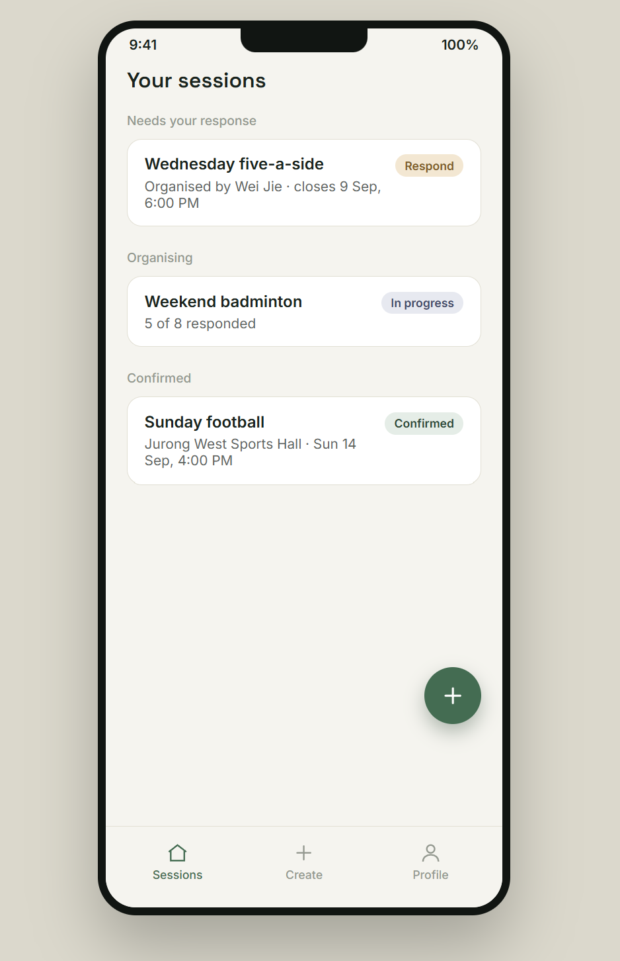 | 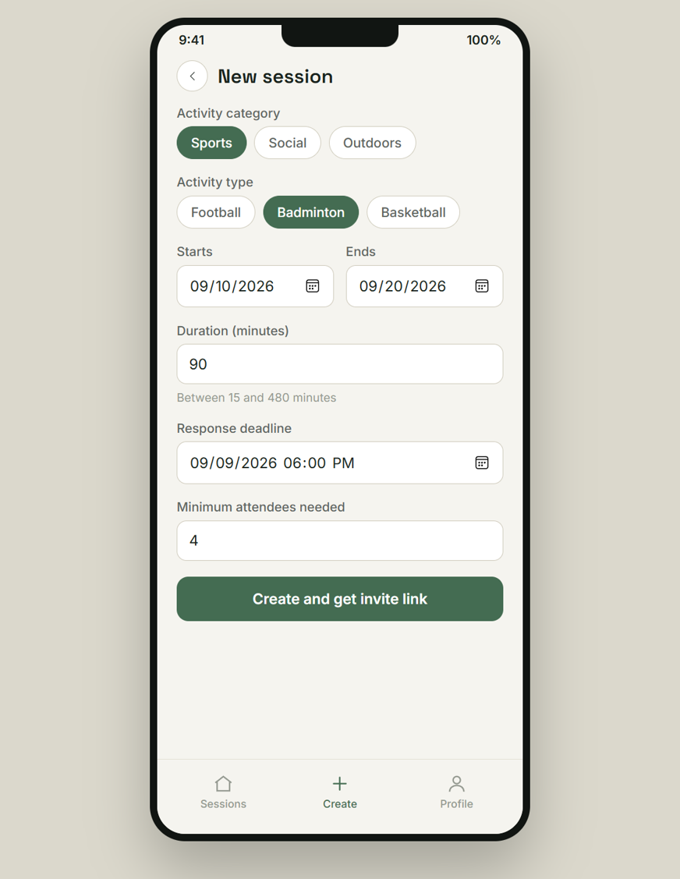 | 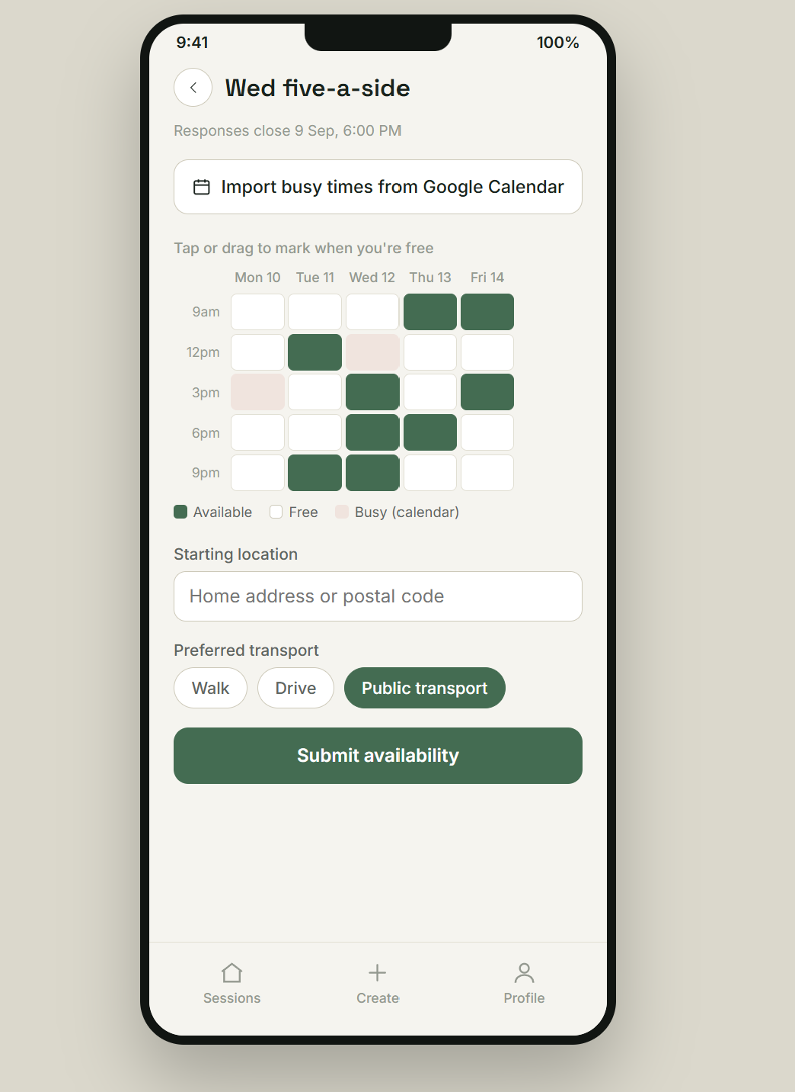
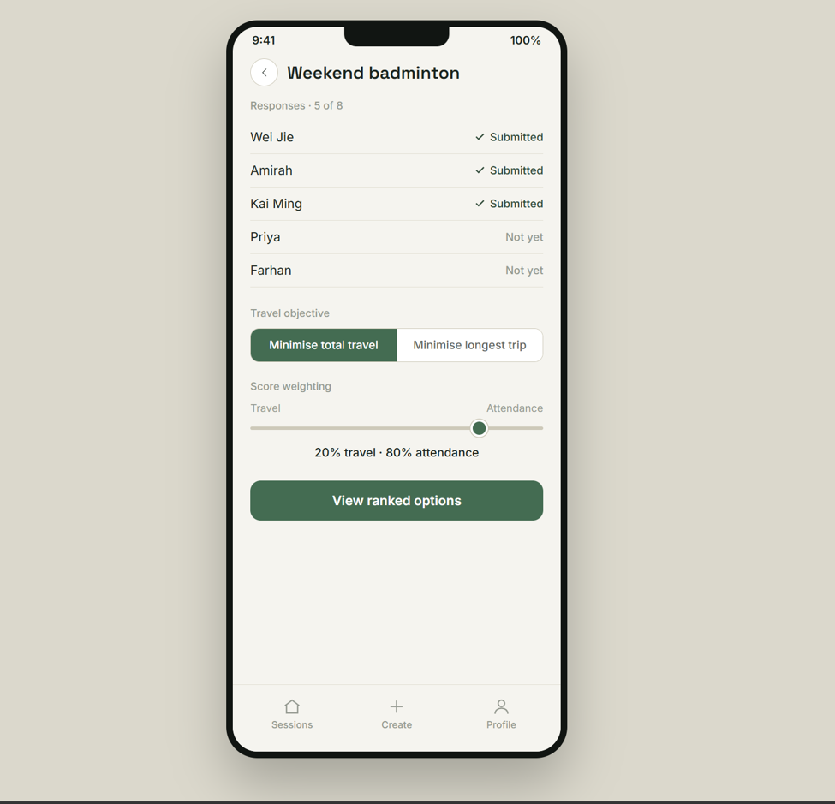 | 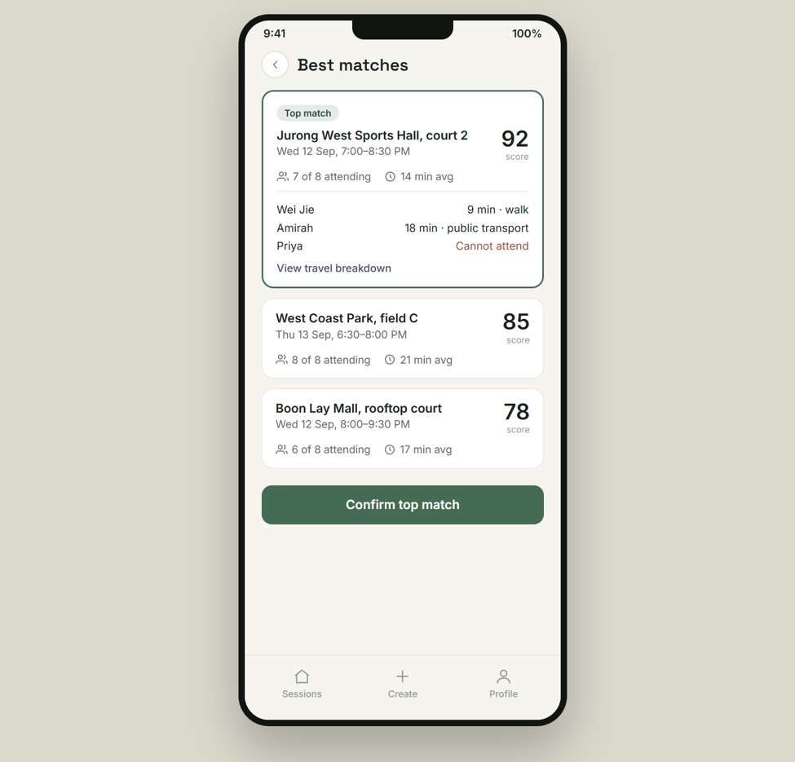 | 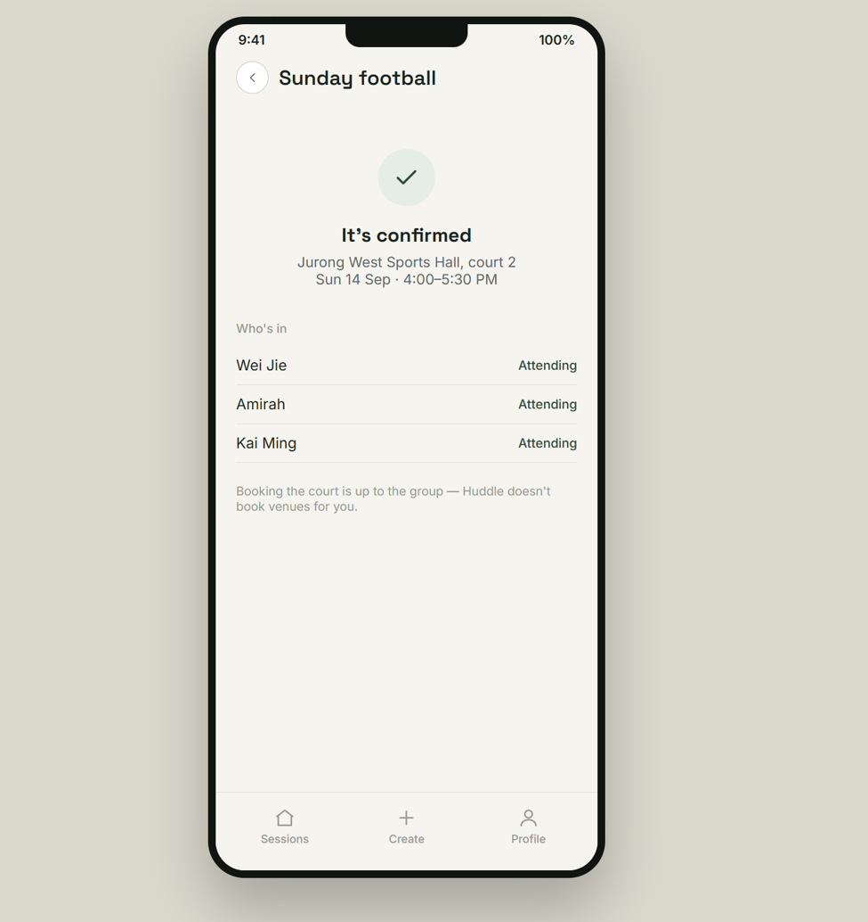

Figure 3 — User interface mockups: Your sessions, New session, Availability entry, Response status, Best matches, Confirmed.

Hardware Interfaces
The System has no direct hardware interfaces. It is a browser-based application and interacts with user devices only through the browser, using standard input methods: touch, including drag gestures on the availability grid, and keyboard and pointer on desktop.
No device sensor is accessed. In particular, the System does not read device GPS or location services, since a Participant’s starting location is entered as an address or postal code and geocoded server-side (FR-B2, FR-B3). No printer, scanner or other peripheral device support is required.

Software Interfaces
Component | Data in | Data out | Purpose and services needed
OneMap API (R1)  SLA national mapping platform | Geocoded coordinates for a submitted address or postal code; route duration for an origin-destination pair under a given transport mode; Venue geolocation. | Address or postal code string (FR-B2); Participant and Venue coordinate pairs with the selected transport mode (FR-D2). | Geocoding of Participant starting locations (FR-B3) and routing-based travel durations for every scored Combination (FR-D2, NFR-8). This is the only mandatory provider; without it no travel score can be computed.
data.gov.sg (R2)  Government open-data portal | Sports-facility and park Venue records: name, address, coordinates, and where published, group-size and advance-booking attributes. | Dataset queries. | Populating and refreshing the Venue catalogue filtered in FR-C3 and tagged in FR-C5. Mall Venue data has no equivalent dataset (TBD-5).
LTA DataMall (R3)  LTA open-data portal | Public-transport travel times. | Origin-destination queries for public-transport legs. | Public-transport travel durations, where OneMap does not itself cover multimodal routing. Whether this interface is required at all is open (TBD-3).
Google Sign-In (OAuth / OpenID Connect) | OAuth consent for basic profile scope (name, email). | Signed-in identity used to create or match a User Account. | Authenticates every Organiser and Participant before they can create or join a Session (Section 2.5, C5). Requested as a separate OAuth scope from the Google Calendar API's free/busy scope below, so a Participant can be signed in without granting calendar access (FR-B8.1).
Google Calendar API v3 (R4) | Free/busy intervals for an authorised Participant; provider event identifiers for events the System created. | OAuth authorisation request; tentative hold event create and delete requests; confirmed event create requests, each carrying Venue and time. | Prefilling the availability grid from a connected calendar (FR-B8), creating tentative holds for candidate Timeslots (FR-B9), deleting non-selected holds on confirmation (FR-B10) and writing the confirmed event (FR-E6). Only free/busy data is read; event titles, descriptions, attendees and unrelated content are never collected (NFR-14). This is a separate OAuth grant from the Google Sign-In identity scope above; declining it does not prevent sign-in (FR-B8.1).
Backend database | Session, Participant, AvailabilityRecord, Venue, Combination and CalendarEvent records as defined in Appendix A and Appendix B. | Persisted records and derived scores. | Durable storage accessible only by the System’s own backend services (NFR-9), on a SQL-compliant engine (NFR-16).

Shared data and implementation constraint. Every external client above must sit behind a stable internal interface, decoupled from the Feasibility and Scoring engine, so that a provider can be substituted without modifying scoring code (NFR-15). External-service status — received, unavailable or error — must be represented explicitly in the data model and kept distinct from invalid user input and from normal feasibility exclusion (Appendix B; NFR-3).

Communications Interfaces
Element | Requirement
Transport protocol | All communication between the browser client and the backend, and between the backend and every external provider, must use HTTPS. No personal data may be transmitted over an unencrypted channel.
Message format | Client-to-backend and backend-to-provider exchanges use HTTP request/response with JSON payloads over the providers’ published REST interfaces.
Authorisation | Google Calendar access uses OAuth 2.0. The System must request free/busy read scope plus the minimum additional scope needed to create and delete events it created itself, and no calendar-content scope (NFR-14). Credentials are held by reference in the backend and kept out of client-side code and ordinary logs.
Session invitation | A Session is reached through a URL containing a unique, difficult-to-guess Invitation Token (FR-A2). The token is non-public Access Data and must not appear on public pages or in ordinary logs.
Notification | No email, SMS or push-notification interface is used. All status changes are communicated by the Session’s shared page (FR-A5.1, FR-E5; constraint C4).
Synchronisation | Candidate-generation and scoring runs are triggered by user action rather than by a schedule (Section 4.3). Withdrawal of an Availability Record must propagate atomically to any in-progress scoring computation (NFR-11).
Rate and volume | External routing calls must be bounded by pruning candidates on straight-line distance before routing (constraint C8). No specific data-transfer rate is required; the scoring-and-rendering budget, after external calls complete, is the 5-second target in NFR-1.

System Features
The functional requirements are organised by system feature. The five features follow the system’s operating sequence — Session Startup, Availability Collection, Candidate Generation, Feasibility and Scoring, and Results and Confirmation — and correspond to the FR identifier prefixes A to E defined in Section 1.2. Priority is stated once per feature and is inherited by every requirement within it.

Session Startup
4.1.1 Description and Priority
An Organiser creates a Session by choosing an activity category and activity type, a date range and a duration, and receives a shareable invitation link. The Organiser also sets the response deadline and the Minimum-Attendee Threshold that later govern collection and feasibility, and may cancel the Session at any point before confirmation.
Priority: High. Nothing else in the product can occur without a Session and its invitation link, and the parameters set here are inputs to every subsequent feature.
4.1.2 Stimulus/Response Sequences
UC-01 Create Session (Organiser). Precondition: none; this is the Session lifecycle's entry point.
1.The Organiser selects Create Session.
2.The Organiser enters the session name, activity, possible dates, duration, minimum attendance and response deadline.
3.The System checks the validity of the information provided.
4.The System creates the Session and generates a participation link.
5.The System displays the link and the Session page.
A lternative flow (at step 3): if a required field is missing or fails validation (FR-A1.1, FR-A3.1), the System displays a field-level error and returns to step 2. Postcondition: a new Session is created and Participants can join it.

UC-02 Manage Session (Organiser). Precondition: the Session exists and its SessionStatus is Active.
1.The Organiser opens the Session page.
2.The System displays the current Session details.
3.The Organiser changes the dates, duration, attendance requirement or deadline.
4.The System checks the validity of the changes and saves them.
5.The System marks previous recommendations as outdated if the changes affect them.
Alternative flow (at step 4): if the new details are invalid, the System keeps the previous settings and shows an error message. Postcondition: the latest valid Session settings are saved.

UC-04 Cancel Session (Organiser). Precondition: the Session exists and has not been cancelled.
1.The Organiser selects Cancel Session.
2.The System asks the Organiser to confirm the cancellation.
3.The Organiser confirms the cancellation.
4.The System changes the Session status to Cancelled.
5.The System stops accepting new or updated responses.
Alternative flow: if the Organiser does not confirm, the Session remains unchanged. Postcondition: the Session is cancelled and cannot be used for further planning.
4.1.3 Functional Requirements
Tan-shaded rows are sub-requirements decomposed from the requirement directly above them.
ID | Requirement | Actor | Input | Output
FR-A1 | The Organiser must be able to create a Session by specifying an activity category, an activity type, a date range, and a session duration. | Organiser | Activity category; activity type; start and end date; duration in minutes. | Session record created with a unique identifier.
FR-A1.1 | The session duration must be a positive integer number of minutes, at least 15 and at most 480. | System | Submitted duration (FR-A1). | Duration accepted, or rejected with a validation message.
FR-A2 | The System must generate a unique, shareable invitation link for every created Session. | System | Session identifier (FR-A1). | URL string bound to that Session.
FR-A3 | The Organiser must be able to set a response deadline for a Session. | Organiser | Session identifier; deadline date-time. | Updated Session record with response deadline.
FR-A3.1 | The response deadline must be a date-time earlier than the Session’s date-range start. | System | Submitted deadline (FR-A3); Session date range (FR-A1). | Deadline accepted, or rejected with a validation message.
FR-A4 | The Organiser must be able to set a Minimum-Attendee Threshold for a Session. | Organiser | Session identifier; minimum attendee count. | Updated Session record with Minimum-Attendee Threshold.
FR-A5 | The Organiser must be able to cancel a Session prior to confirmation. | Organiser | Session identifier. | Session status set to Cancelled.
FR-A5.1 | If a Session is cancelled, the System must display the cancellation on the Session’s shared page to every visitor. | System | Cancelled Session (FR-A5). | Session page shows Cancelled status; no push, SMS or email notification is sent (see Section 2.5, C4).

Availability Collection
4.2.1 Description and Priority
Participants reach a Session through its invitation link and supply the three inputs the scoring engine needs: when they are free, where they would travel from, and how they would travel. Availability is entered on a date-range grid and may optionally be prefilled from a connected Google Calendar. Responses may be modified or withdrawn before the response deadline, and the Organiser can see who has responded. The System geocodes each starting location and may place tentative holds in connected calendars.
Priority: High. Every score in Section 4.4 is derived from data collected here, and the product produces no output without it. The Google Calendar path within this feature is Medium priority, since manual entry is a complete fallback (FR-B8.1).
4.2.2 Stimulus/Response Sequences
UC-05 Join Session (Participant). Precondition: the Participant has received a valid participation link.
1.The Participant opens the participation link.
2.The System checks whether the Session exists and is still open.
3.The System shows the Session information.
4.The Participant signs in with a Google Account; a User Account is created automatically on first sign-in.
5.The Participant submits the required planning information.
Alternative flow: if the link is invalid, the System shows an error; if the Session is closed, the System shows its current status instead. Postcondition: the Participant is joined to the Session and can proceed to submit availability (UC-06).

UC-06 Submit Availability (Participant). Precondition: the Participant has joined an open Session and the response deadline has not passed.
1.The System displays the possible dates and time blocks.
2.The Participant selects the time blocks in which they are free.
3.The Participant reviews and submits the selection.
4.The System checks that the selected blocks are valid.
5.The System saves the availability and marks the Participant as submitted.
Alternative flow: if no time block is selected, the System asks the Participant to confirm that they are unavailable. Postcondition: the Participant’s choice is stored for the recommendation process.
UC-07 Manage Response (Participant). Precondition: the Participant has already submitted a response and the Session is still open.
1.The Participant opens their existing response.
2.The Participant chooses to edit the response.
3.The System asks the Participant to confirm the change.
4.The system saves the updated response (FR-B5).
5.The System marks previous recommendations as outdated.
Alternative flow (at step 2): if the Participant withdraws instead, the System asks for confirmation and, on confirmation, sets the Participant's status to Withdrawn (FR-B6), skipping steps 3 to 5.
Alternative flow: if the response deadline has passed, the System does not allow the response to be changed. Postcondition: the latest response status is stored.

UC-08 Submit Starting Location and Transport Mode (Participant; supporting system: OneMap). Precondition: the Participant has joined an open Session.
1.The Participant enters an address, building name or postal code.
2. The System uses OneMap to find matching locations.
3.The Participant selects the correct starting location.
4.The Participant selects a preferred transport mode.
5.The System saves the location and transport mode.
Alternative flow: if no location is found, the System asks the Participant to change the search information. Alternative flow: if OneMap is unreachable, the System marks the starting location as unavailable and allows the Participant to retry (NFR-3). Postcondition: a valid starting location and transport mode are saved for travel-time calculation.
UC-03 View Response Status (Organiser). Precondition: the Session has been created and an invitation link generated.
1. The Organiser opens the response status page.
2. The System retrieves the latest Participant responses.
3. The System shows which Participants have submitted, withdrawn or not yet replied.
4. The Organiser can refresh the page to view updated information.
Alternative flow: if no Participant has joined, the System shows that there are no responses yet. Postcondition: no Session information is changed.
4.2.3 Functional Requirements
ID | Requirement | Actor | Input | Output
FR-B1 | A Participant must be able to submit their availability for a Session via its invitation link, on a date-range availability grid (When2Meet-style click/drag selection). | Participant | Invitation link; click/drag selections on the Session’s date-range grid. | Availability Record created and linked to the Session.
FR-B2 | A Participant must be able to submit their starting location as a home address or postal code. | Participant | Address or postal code. | Location stored on the Participant’s Availability Record.
FR-B3 | The System must convert a Participant’s submitted address or postal code into geographic coordinates. | System | Address or postal code (FR-B2). | Geocoded coordinates stored via OneMap.
FR-B3.1 | If a submitted address or postal code cannot be geocoded, the System must reject it and prompt the Participant to re-enter it. | System | Ungeocodable address or postal code. | Rejection message shown; Participant prompted to resubmit.
FR-B4 | A Participant must be able to select a preferred transport mode (walk, drive, or public transport). | Participant | Selected transport mode. | Preference stored on the Participant’s Availability Record.
FR-B5 | A Participant must be able to modify their previously submitted availability before the Session’s response deadline. | Participant | Updated availability selections. | Availability Record updated.
FR-B6 | A Participant must be able to withdraw their previously submitted availability before the Session’s response deadline. | Participant | Withdrawal request. | Availability Record marked Withdrawn (retained, not deleted); Participant excluded from candidate scoring.
FR-B7 | The Organiser must be able to view which invited Participants, identified by their signed-in User Account, have and have not yet submitted their availability. | Organiser | Session identifier. | Response-status list (submitted / not yet submitted) per Participant.
FR-B8 | A Participant must be able to authorize the System to import busy blocks from a connected Google Calendar to prefill their availability. | Participant | OAuth authorization. | Calendar connection established; busy blocks pre-filled onto the availability grid.
FR-B8.1 | If a Participant declines calendar authorization, the System must fall back to the manually submitted availability grid (FR-B1) alone. | System | Declined authorization. | Availability Record built from FR-B1 alone; no calendar dependency.
FR-B9 | The System must create a tentative hold event in a Participant’s connected Google Calendar for each candidate Timeslot still under consideration for a Session. | System | Candidate Timeslots (Section 4.3); connected calendar. | Tentative Hold Events created.
FR-B9.1 | The System must create every Tentative Hold Event as free (non-blocking) time, and must exclude events it created itself when importing free/busy data (FR-B8), so that its own holds are never read back as busy. | System | Tentative Hold Events (FR-B9); calendar free/busy import (FR-B8). | Holds do not mark the Participant as busy on the availability grid.
FR-B10 | Once a Session is confirmed, the System must delete every Tentative Hold Event for that Session’s non-selected candidate Timeslots from Participants’ connected Google Calendars. | System | Confirmed Session (FR-E4). | Non-selected Tentative Hold Events removed.

Candidate Generation
4.3.1 Description and Priority
The System builds the candidate set that Section 4.4 scores: every Timeslot of the Session’s duration within its date range, and the Venues nearest the Participants that support the Session’s activity type. Candidate Timeslots are enumerated when the Session is created and are regenerated only if the Organiser changes the date range or duration (UC-02); the per-Timeslot attendance count (FR-C2) is re-evaluated as Availability Records are submitted, modified or withdrawn. The Geographic Centroid and Venue shortlist depend on Participants’ starting locations, so they are calculated when the Organiser runs Generate Recommendations (UC-09) and recalculated on every later run. Neither step runs on a recurring or weekly schedule.
Priority: High. The shortlist produced here bounds the number of routing calls made in Section 4.4 and is therefore what makes the performance target in NFR-1 attainable.
4.3.2 Stimulus/Response Sequences
UC-09 Generate Recommendations, steps 1–3 (Organiser). Precondition: the Session settings and at least one valid Participant response are available.
1. The Organiser selects Generate Recommendations.
2. The System finds time slots that meet the minimum attendance requirement.
3.The System retrieves Venues that support the selected activity.
Alternative flow (at step 2): if no time slot meets the attendance requirement, the System informs the Organiser and the use case ends; no candidate set is produced until availability or the Minimum-Attendee Threshold changes (UC-02). If at least one time slot qualifies, steps 4 to 6 continue in Section 4.4.2. Postcondition: a candidate Timeslot set and a Venue shortlist exist for the Session.
4.3.3 Functional Requirements
ID | Requirement | Actor | Input | Output
FR-C1 | The System must enumerate every candidate Timeslot within a Session’s date range whose length matches the Session’s duration, computed when the Session is created and regenerated whenever the Organiser changes the Session’s date range or duration (UC-02), rather than on a recurring schedule. | System | Session date range and duration (FR-A1). | List of candidate Timeslots.
FR-C2 | The System must compute, for each candidate Timeslot, the number of Participants who are available. | System | Candidate Timeslots (FR-C1); Availability Records (FR-B1/FR-B5). | Attendance count per candidate Timeslot, re-evaluated whenever an Availability Record is submitted, modified, or withdrawn.
FR-C3 | The System must filter the venue catalogue to Venues that support the Session’s activity type. | System | Activity type (FR-A1); venue catalogue. | Filtered venue list.
FR-C4 | The System must shortlist the filtered Venues to the N Venues nearest to the geographic centroid of Participants’ locations, using straight-line distance, where N is a fixed System default rather than an Organiser-set value. The centroid and shortlist must be calculated each time the Organiser runs Generate Recommendations (UC-09), using the locations on active Availability Records at that moment. | System | Filtered venue list (FR-C3); Participant coordinates (FR-B3). [N: see Appendix C, TBD-2] | Geographic Centroid computed; shortlisted candidate Venue list (nearest N).
FR-C5 | The System must tag each shortlisted Venue with its Venue Category (Sports Facility, Park, or Mall). | System | Venue record. | Venue Category attached.
FR-C6 | For a Sports Facility Venue, the System must retrieve its minimum group size, optimal group size, and required advance-booking window. | System | Sports Facility venue record. | Group-size and booking-window constraints attached to the Venue.

Feasibility and Scoring
4.4.1 Description and Priority
Each pairing of a candidate Timeslot with a shortlisted Venue is a Combination. The System discards Combinations that fail an attendance, journey-time, Venue group-size or advance-booking constraint, retrieves routing-based travel durations for those that survive, and scores them on attendance and travel under the Organiser’s chosen Travel Objective and weighting. The result is a ranked Combined Score.

Priority: High. This feature is the product’s differentiator, the joint optimisation of time against real travel time stated in Section 1.4. Five values used here remain unresolved: the maximum journey-time threshold, the default attendance threshold, the public-transport routing provider, the optimal-group-size effect and the tie-break rule (Appendix C, TBD-1 to TBD-4 and TBD-9).
4.4.2Stimulus/Response Sequences
UC-09 Generate Recommendations, steps 4 to 6 (Organiser). Precondition: continues from Section 4.3.2 having produced a non-empty candidate Timeslot set and Venue shortlist, and the Organiser has selected a Travel Objective and score weighting (FR-D6, FR-D9).

1. The System calculates travel time for the possible Venues.
2. The System scores each venue-time option using attendance and the Organiser’s selected Travel Objective (total or maximum individual travel time).
3. The System displays the options from highest to lowest score.
Alternative flow: if an external service fails, the System shows an error and allows the Organiser to try again. Postcondition: a ranked list of venue-time recommendations is available.
UC-10 Calculate Travel Time (System; supporting system: OneMap). Precondition: Participant locations, transport modes and shortlisted Venues are available.
1. The System prepares a route request for each Participant and possible Venue.
2. The System sends the requests to OneMap using the selected transport modes.
3. OneMap returns the estimated travel times.
4. The System stores the travel-time results.
5. The System calculates the total, average and maximum travel time for each Venue.
Alternative flow: if a route cannot be calculated, the System marks that travel time as unavailable. Postcondition: travel-time information is ready for the scoring process.
4.4.3 Functional Requirements
ID | Requirement | Actor | Input | Output
FR-D1 | The System must exclude any Timeslot-Venue Combination whose attendance count is below the Session’s Minimum-Attendee Threshold. | System | Attendance count (FR-C2); Minimum-Attendee Threshold (FR-A4). | Below-threshold Combinations excluded from scoring.
FR-D2 | The System must retrieve the travel duration between each available Participant’s location and each shortlisted Venue. | System | Participant coordinates (FR-B3); shortlisted Venue coordinates (FR-C4); transport mode (FR-B4). | Travel-duration matrix, via OneMap routing (and LTA DataMall for public-transport legs — see Appendix C, TBD-3).
FR-D3 | The System must exclude a Combination if any individual attending Participant’s journey time to that Venue exceeds a maximum individual-journey-time threshold. | System | Travel-duration matrix (FR-D2). [Threshold value: see Appendix C, TBD-1] | Combinations exceeding the individual cap excluded.
FR-D4 | For a Combination at a Sports Facility Venue, the System must exclude it if the attendance count is below that Venue’s minimum group size (FR-C6). | System | Attendance count (FR-C2); Venue minimum group size (FR-C6). | Under-sized Combinations excluded.
FR-D5 | For a Combination at a Sports Facility Venue, the System must exclude it if the Timeslot falls inside that Venue’s required advance-booking window (FR-C6). | System | Candidate Timeslot; current date-time; Venue booking window (FR-C6). | Too-soon-to-book Combinations excluded.
FR-D6 | The Organiser must be able to select a Travel Objective from a defined set of options (e.g. minimize total travel time, minimize the maximum individual travel time). | Organiser | Selected Travel Objective. | Selected objective applied in FR-D7.
FR-D7 | The System must compute a travel score for each remaining Combination according to the Organiser’s selected Travel Objective. | System | Travel-duration matrix (FR-D2); selected Travel Objective (FR-D6). | Travel score per Combination.
FR-D8 | The System must compute an attendance score for each remaining Combination. | System | Attendance count (FR-C2). | Attendance score per Combination.
FR-D9 | The Organiser must be able to adjust the relative weighting between attendance score and travel score used in the Combined Score. | Organiser | Weighting value. | Combined Score (FR-D10) recomputed and Combinations re-ranked.
FR-D9.1 | The weighting must snap to discrete positions in increments of 10%, from 0% (pure travel score) to 100% (pure attendance score). | System | Raw weighting-control input. | Weighting value rounded to the nearest 10% increment before the Combined Score is recomputed.
FR-D10 | The System must compute a Combined Score for each remaining Combination by applying the Organiser’s chosen weighting to its attendance score and travel score. | System | Attendance score (FR-D8); travel score (FR-D7); weighting (FR-D9). | Combined Score per Combination; Combinations ranked in descending order.

Results and Confirmation
4.5.1 Description and Priority
The ranked Combinations are presented with enough supporting detail for the group to trust them: per-Participant travel time and mode, and who can and cannot attend. The Organiser confirms one Combination, which becomes the Session’s outcome, is published on the shared Session page and is written to attending Participants’ connected calendars.
Priority: High for display and confirmation (FR-E1 to FR-E5), since these complete the product’s stated purpose. Medium for the confirmed calendar write-back (FR-E6), which is a convenience on top of an already-communicated outcome and depends on an optional integration.
4.5.2Stimulus/Response Sequences
UC-11 View Ranked Recommendations (Organiser or Participant). Precondition: the System has generated at least one recommendation.
1.The Organiser or Participant opens the recommendation results.
2.The System displays the venue-time options in ranked order.
3.Each option shows the expected attendance, total travel time and maximum individual travel time.
4.The System gives a short explanation of the score.
5.The Organiser may select an option to confirm it (UC-12); a Participant may view an option's detail but cannot confirm it.
Alternative flow: if the Session information has changed, the System marks the results as outdated and asks the Organiser to generate them again. Postcondition: no Session information is changed until an option is confirmed.
UC-12 Confirm Final Plan (Organiser). Precondition: a current ranked recommendation list is available.
1. The Organiser selects one venue-time option.
2. The System displays the selected time, Venue and expected attendance.
3. The System states that live booking availability is not guaranteed.
4. The Organiser confirms the option.
5. The System saves it as the final plan and displays it to Participants.
6.The System displays the Venue’s public name, address and map pin, and states that booking the Venue is the group’s responsibility.
7. The System creates a confirmed calendar event containing the Venue and time in each attending Participant's connected Google Calendar (FR-E6).
Alternative flow: if the Organiser cancels the confirmation, the Session remains open and unchanged. Postcondition: the Session has one final venue-time plan visible to Participants.
4.5.3 Functional Requirements
ID | Requirement | Actor | Input | Output
FR-E1 | The System must display the top-ranked Combinations, including Venue name, address, map pin, date/time, Combined Score, attendance count, and total and maximum individual travel time. | System, viewed by Organiser / Participant | Ranked Combination list (FR-D10). | Top-ranked Combinations rendered.
FR-E2 | The System must display, for a selected Combination, each attending Participant’s travel time and mode. | System, viewed by Organiser / Participant | Travel-duration matrix (FR-D2). | Per-Participant travel time and mode rendered.
FR-E3 | The System must display, for a selected Combination, the list of Participants who can and cannot attend. | System, viewed by Organiser / Participant | Attendance data (FR-C2). | Attendance list rendered.
FR-E4 | The Organiser must be able to confirm a final Combination as the Session’s outcome. | Organiser | Selection of a final Combination. | Combination marked confirmed for the Session.
FR-E5 | Once the Organiser confirms a final Combination, the System must display the confirmed Venue and time on the Session’s shared page to every visitor. | System | Confirmed Combination (FR-E4). | Session page shows confirmed Venue and time; no push, SMS or email notification is sent (see Section 2.5, C4).
FR-E6 | Once a Session is confirmed, the System must create a confirmed calendar event, containing the Venue and time, in each attending Participant’s connected Google Calendar. | System | Confirmed Combination (FR-E4). | Confirmed calendar event created per attending Participant.

Other Nonfunctional Requirements

Performance Requirements
Response time matters here because the Organiser is typically waiting on the result mid-conversation with the group, and because scoring fans out into one routing call per available Participant per shortlisted Venue. The shortlisting step in FR-C4 exists to keep that fan-out bounded.
ID | Requirement | Metric / Acceptance Criteria
NFR-1 | The System must return ranked Combinations for a Session with up to 12 Participants and up to 30 shortlisted Venues within 5 seconds after all required external API calls complete. | 95th-percentile response time under 5 seconds, measured from receipt of the last required external API response to results rendered.
NFR-2 | The System must sustain at least 50 concurrently active Sessions without a measurable increase in per-Session response time. | Candidates are pruned by straight-line distance (FR-C4) before any routing call; load testing confirms no degradation at 50 concurrent Sessions.

The maximum supported number of concurrent Participants per Session is unresolved (TBD-7). NFR-1 assumes 12; if the client requires more, this figure must be revisited.

Safety Requirements
The System does not control physical equipment, dispense medication, handle financial transactions or direct vehicles, and no loss, damage or physical harm arises directly from its operation. No safety certification applies.
Two indirect safety considerations are noted and are handled elsewhere in this document rather than as separate safety requirements. First, the System recommends journeys but does not provide turn-by-turn navigation; travel durations are estimates from a routing provider and are presented as estimates (FR-E2). Second, the System must not imply that a Venue is booked or available: the confirmation flow states explicitly that live booking availability is not guaranteed and that booking remains the group’s responsibility (Section 4.5.2, step 3).

Security Requirements
The product collects home addresses and calendar data from Participants who sign in with a Google Account, which makes access control and data minimisation the dominant security concerns.
ID | Requirement | Metric / Acceptance Criteria
NFR-9 | All Session, Availability Record, and Venue data must be stored in a durable backend database, accessible only by the System’s own backend services. | No client-side code or third party has direct database access, verified via architecture review.
NFR-12 | The System must comply with Singapore’s Personal Data Protection Act (PDPA) in its collection, storage and use of Participants’ personal data, including home addresses and calendar data. | A PDPA compliance review is completed and signed off before launch; no personal-data field is collected without a stated purpose.
NFR-13 | A Participant’s exact home address must never be shown to other Participants — only computed travel time may be shared. | Manual QA confirms no address field is rendered to any user other than its owner.
NFR-14 | Calendar OAuth integration (FR-B8 to FR-B10, FR-E6) must request free/busy read scope plus only the minimum additional scope needed to create and delete events the System itself created; it must never request access to event titles, descriptions, attendees or other calendar content. | The OAuth consent screen and granted scope list contain no calendar-content scopes.

Authentication and authorisation. Every Participant and Organiser signs in with a Google Account, which establishes a stable User Account identity; the Session's Invitation Token identifies which Session that identity is joining and is kept out of public pages and ordinary logs. No password is stored by the System. OAuth credentials for a Calendar Connection are held by backend reference only and are never exposed to client-side code or ordinary logs. The mechanism authorising Organiser-only actions (FR-A3 to FR-A5, FR-D6, FR-D9, FR-E4) checks whether the signed-in User Account matches the Session's OrganiserParticipantID (TBD-11 resolved).

Software Quality Attributes
Reliability
ID | Requirement | Metric / Acceptance Criteria
NFR-3 | The System must degrade gracefully when an external data source (OneMap, LTA DataMall, Google Calendar) is unreachable, rather than failing the whole request. | If an external API is down, results still return with the affected data — travel time or calendar sync — visibly marked “unavailable”.
NFR-4 | After a System restart, full functionality must be restored within 5 minutes. | Time from restart to first successfully served request is measured and does not exceed 5 minutes in deployment testing.
NFR-11 | Withdrawing a submitted Availability Record (FR-B6) must atomically remove it from every in-progress Feasibility and Scoring computation. | No withdrawn Availability Record is reflected in a Combination scored after the withdrawal completes, verified by integration test.

Usability
ID | Requirement | Metric / Acceptance Criteria
NFR-5 | The availability grid (FR-B1) must be usable on a mobile-width screen with no training beyond the one-time Google sign-in. | A first-time Participant, once signed in, completes a full availability submission in under 60 seconds in usability testing; the one-time Google sign-in step is measured and reported separately.
NFR-6 | The System must run as a mobile-responsive web application accessible from modern browsers on iOS, Android and desktop. | Core flows (availability entry, viewing results) render correctly on a 375 px-wide viewport and in the two most recent versions of Chrome, Safari and Edge.
NFR-7 | Calendar integration (FR-B8) must support at minimum Google Calendar via OAuth. | The OAuth import path is demonstrated end-to-end in acceptance testing.

Accuracy
ID | Requirement | Metric / Acceptance Criteria
NFR-8 | Travel-duration estimates used in scoring (FR-D2) must be drawn from live multimodal routing data, not straight-line approximation, for every Combination that survives the straight-line shortlist (FR-C4). | A sample audit confirms every scored Combination’s travel time traces to a routing-API response, never to the FR-C4 shortlisting distance.

Maintainability
ID | Requirement | Metric / Acceptance Criteria
NFR-15 | The data-fetch layer (OneMap / LTA DataMall / Google Calendar clients) must be decoupled from the Feasibility and Scoring engine behind a stable internal interface. | A data provider can be replaced without modifying the Section 4.4 scoring code.
NFR-16 | The database must be built on a standard, SQL-compliant database engine, replaceable with any other compliant provider without rewriting the Feasibility and Scoring engine. | A proof-of-concept migration to an alternate SQL-compliant engine succeeds with no changes to the Section 4.4 code, verified in architecture review.

Relative preference. Accuracy of travel estimates (NFR-8) takes precedence over response time (NFR-1): a slower result drawn from live routing is preferred to a fast result drawn from straight-line approximation. Ease of use (NFR-5) takes precedence over feature depth, since most Participants use the product once and receive no training.

Business Rules
Role-based operating principles.
• Each Session has exactly one Organiser; every other invitee holds the Participant role.
• Only the Organiser may set or change Session parameters, select the Travel Objective, adjust the scoring weighting, confirm the final Combination, or cancel the Session.
• Any Participant, including the Organiser, may submit, modify or withdraw their own availability, starting location and transport mode.
• No Participant may view, modify or withdraw another Participant’s response, or view another Participant’s starting location.
• A Session may be cancelled only before confirmation; a confirmed Session is terminal.
Data consistency rules.
• Participant, availability, Timeslot, shortlist and Combination records stay within the same Session.
• A withdrawn response no longer contributes to attendance, feasibility or scoring.
• Straight-line distance supports Venue shortlisting only; routing duration supports final travel scoring.
• Changes to availability, location, transport mode, Venue data, weights or travel objective can change derived results, which must be recalculated.
• Only a feasible Combination from the same Session may become the confirmed result.
• External-service failure remains distinct from invalid user input and from normal feasibility exclusion.
• A Participant has at most one current active Availability Record per Session.
• Attendance states NO_RESPONSE and WITHDRAWN remain distinct from UNAVAILABLE.
• The System may update or delete only calendar events it created itself, identified by their provider event reference.
Data handling and classification rules.
Data | Classification | Access | Handling
Participant address / coordinates | Restricted Personal Data | Owner and authorised backend functions | Used for geocoding, centroid and routing; never displayed to other Participants.
Availability intervals | Session Personal Data | Owner and relevant Session functions | Used only for scheduling the related Session.
Calendar free/busy information | Restricted Personal Data | Owner and authorised Calendar functions | Only free/busy data from existing events is collected.
Existing Calendar event content | Not Collected | None | Titles, descriptions, attendees and unrelated content stay outside the integration.
OAuth credentials | Secret | Authorised backend functions | Kept away from client-side code and ordinary logs.
Invitation Token | Access Data | Intended invitees and authorised backend functions | Non-public; never shown on public pages or placed in ordinary logs.
Travel duration / attendance | Derived Session Data | Relevant Session views | May be shown without exposing a private starting location.
Venue information | Public / External Data | Session users | Name, address and map position may be displayed.
Scores and ranks | Derived System Data | Session users | Recalculated when relevant source data changes.

Other Requirements
Database requirements
ID | Requirement | Metric / Acceptance Criteria
NFR-10 | The database must be backed up automatically at least once every 24 hours. | Backups are retained for at least 30 days and a restore is verified quarterly.

The logical data model the database must support — entities, attributes, permitted values and relationships — is specified in Appendix A and Appendix B. Physical schema design, indexing and the choice of engine are design decisions, subject to NFR-16. The production hosting location is unresolved and may be constrained by PDPA data residency (TBD-8).
Legal and compliance requirements
ID | Requirement | Metric / Acceptance Criteria
NFR-17 | The System must use only documented, authorized public APIs under their published terms of use. | No undocumented endpoint is called without separate written confirmation of permissibility; verified in architecture review.

PDPA obligations are specified as security requirements in Section 5.3 (NFR-12 to NFR-14) and as data-handling rules in Section 5.5.
Internationalisation and localisation requirements
The initial release targets Singapore only and is delivered in English. No translation, currency handling or alternative date-format support is required.
Time zone handling is nevertheless a requirement rather than an assumption: every Session stores a Session Timezone, and all Session deadlines, availability intervals, Candidate Timeslots and Calendar Events must be interpreted and displayed consistently within it. This matters even in a single-timezone deployment, because Google Calendar returns free/busy data with explicit offsets that must be reconciled against manually entered grid selections.
Validation approach
Before this SRS is taken into design, it will be reviewed against a checklist for completeness, consistency, unambiguity and correctness, and walked through with the stakeholders it is written for, namely Participants and Organisers. A storyboard or clickable prototype of the availability grid and the ranked-results screen will then be produced to validate the Combined Score and Travel Objective controls (FR-D6 to FR-D10) with stakeholders before implementation begins. The mockups in Section 3.1 are the current state of that storyboard.
Every item in Appendix C must be closed, or explicitly accepted as a documented assumption, before the affected requirement is implemented.
Appendix A: Glossary
A.1 Acronyms and external services
Term | Definition
FR / NFR | Functional Requirement / Non-Functional Requirement.
OneMap | Singapore Land Authority’s national mapping platform, used here for geocoding, routing and venue geolocation.
LTA DataMall | Land Transport Authority’s open-data portal, used here for public-transport travel-time data (pending TBD-3).
data.gov.sg | Singapore’s whole-of-government open-data portal; source for venue datasets (sports facilities and parks).
PDPA | Singapore’s Personal Data Protection Act, governing the collection, use and disclosure of personal data; relevant to Section 5.3.
Google Calendar API | Google’s calendar service and its OAuth-based API, used to import Participant free/busy data and write tentative and confirmed Session events back (FR-B8 to FR-B10, FR-E6).
OAuth | The delegated authorisation protocol by which a Participant grants the System scoped access to their Google Calendar without sharing credentials.
TBD | To Be Determined: a point not yet resolved. All TBD items are listed in Appendix C.
UUID | A unique identifier generated by the System.
Enum | A value selected from a stated list.

A.2 Domain terms
Term | Definition
Session | A proposed group activity. It stores the activity, possible date range, duration, response deadline, minimum attendance, travel objective, scoring weights and current status.
Organiser | The Participant who creates and manages a Session, shares the invitation link, reviews the suggestions and confirms or cancels the Session.
Participant | A person invited to a Session who can submit, update or withdraw availability, starting location and transport preference.
Participant Role | Shows whether a person is the Organiser or a Participant. Each Session has one Organiser, while other invitees take the Participant role.
User Account | A person's persistent sign-in identity, established with a Google Account. It links that person's Participant records across every Session they join or organise.
Activity Category | A general grouping such as Sports. It organises the supported Activity Types without replacing the specific activity selected for a Session.
Activity Type | The selected activity, such as Football. It is used to identify Venues that support the Session activity.
Session Duration | The planned length of the activity. It is used with a Candidate Timeslot start time to calculate its end time.
Session Date Range | The earliest and latest date and time in which the activity may take place. Candidate Timeslots are generated only within this range.
Session Timezone | The timezone used to interpret and display all Session deadlines, availability intervals, Candidate Timeslots and Calendar Events consistently.
Response Deadline | The final date and time for Participants to submit, edit or withdraw their responses before suggestions are prepared.
Minimum Attendee Threshold | The smallest number of available Participants needed for an option to remain feasible. The default value is still to be confirmed (TBD-2).
Travel Objective | The Organiser’s choice to minimise either the group’s total travel time or the longest individual journey.
Session Status | The current Session state: active while planning, confirmed after the final choice, or cancelled.
Invitation Token | A unique, difficult-to-guess value in the Session invitation link. It is non-public Access Data and is kept out of public pages and ordinary logs.
Response Status | Shows whether an invited Participant has not submitted, has submitted, or has withdrawn a response. Identity is established by the signed-in User Account (TBD-10 resolved).
Availability Record | A Participant’s current response for one Session, including starting location, transport mode, availability intervals and whether the response is active or withdrawn.
Submission Source | Shows whether an Availability Record was prepared manually or with help from Google Calendar.
Starting Location | An address or postal code entered by a Participant and converted to coordinates for calculations. It is private and is not shown to other Participants.
Location Validation Status | Shows whether a starting location is pending, valid, invalid or unavailable. Invalid input is kept separate from a geocoding service failure.
Transport Mode | The Participant’s selected way of travelling: walking, driving or public transport. It is used for routing-based travel estimates.
Availability Interval | A period during which a Participant is available or busy. It can be entered manually or obtained from Google Calendar free/busy data.
Calendar Connection | An optional Google Calendar authorization linked to a Participant.
Calendar Free/Busy Data | Busy or free time read from an existing Calendar. Event titles, descriptions, attendees and unrelated event content are not collected.
Calendar Event | A tentative hold or confirmed Session event created through a Calendar Connection. Its provider reference allows the System to update or delete only events that it created.
Candidate Timeslot | A possible Session time generated inside the date range using the Session Duration. The interval between possible start times is still to be confirmed (TBD-13).
Timeslot Attendance | The calculated state of one Participant for one Candidate Timeslot: available, unavailable, no response or withdrawn.
Attendance Count | The number of Participants available for a Candidate Timeslot. It is used for feasibility checking and scoring.
Venue | A sports facility, park or mall that may host the activity. It includes a public name, address, coordinates and source; the Mall Venue source is still to be confirmed (TBD-5).
Venue Category | The general type of Venue, such as a sports facility, park or mall. It helps the System organise Venue choices.
Venue Activity | A link showing that a Venue supports an Activity Type and whether that support has been verified.
Venue Capacity | A Venue’s minimum or optimal group-size information. How the optimal value affects scoring still needs clarification (TBD-4).
Venue Data Source | The documented source from which Venue information is obtained. Only authorised sources are used.
Advance Booking Window | A Venue condition showing how far in advance it can be booked. A Candidate Timeslot inside the restricted period is excluded.
Venue Shortlist | The nearest eligible Venues retained for one Session. It is calculated each time the Organiser runs Generate Recommendations; its size still needs clarification (TBD-2).
Shortlist Position | The nearest-first position assigned to a Venue after straight-line distances are compared for one Session.
Geographic Centroid | The centre point calculated from valid Participant coordinates for Venue shortlisting. Individual private locations are not displayed.
Straight Line Distance | The direct distance from the Geographic Centroid to a Venue. It is used only for shortlisting, while final travel calculations use routing data.
Combination | One Candidate Timeslot paired with one shortlisted Venue. Each Combination is checked, scored and ranked before the Organiser chooses an option.
Combination Status | Shows whether a Timeslot-Venue Combination is still a candidate, has been excluded, or has become the confirmed choice.
Feasibility Status | Shows whether a Combination is pending, feasible, excluded or missing required external data. Data unavailable is different from normal exclusion.
Exclusion Reason | Explains why an option is removed, such as low attendance, excessive journey time, an unmet Venue group size or an advance-booking restriction.
Travel Estimate | A routing-based one-way journey time from an attending Participant’s Starting Location to a Venue using the selected Transport Mode. The public-transport provider is still to be confirmed (TBD-3).
Maximum Journey Time Threshold | The longest journey allowed for an attending Participant. A Combination is excluded when the threshold is exceeded; its value is still to be confirmed (TBD-1).
Score Components | Attendance Score represents expected attendance and Travel Score represents the selected travel objective. Their exact calculation and normalisation are not yet specified (TBD-15).
Scoring Weights | The percentages chosen by the Organiser for attendance and travel. Attendance changes in 10 percent steps and the two weights total 100 percent.
Combined Score and Rank | The weighted result used to order feasible Combinations. A higher-ranked option is shown earlier; the tie-break rule for equal scores is still to be confirmed (TBD-9).
Final Selection | The feasible Candidate Timeslot and Venue confirmed by the Organiser and stored as the Session’s final choice.
External Service Status | Shows whether geocoding, routing, Venue or Calendar data was received successfully, is unavailable, or returned an error.

Appendix B: Analysis Models
B.1 Use case diagram
Figure 4 shows the UML use-case view of the system, with the functional areas corresponding to the five features in Section 4. Repeated actor labels are layout copies of the same UML actor.
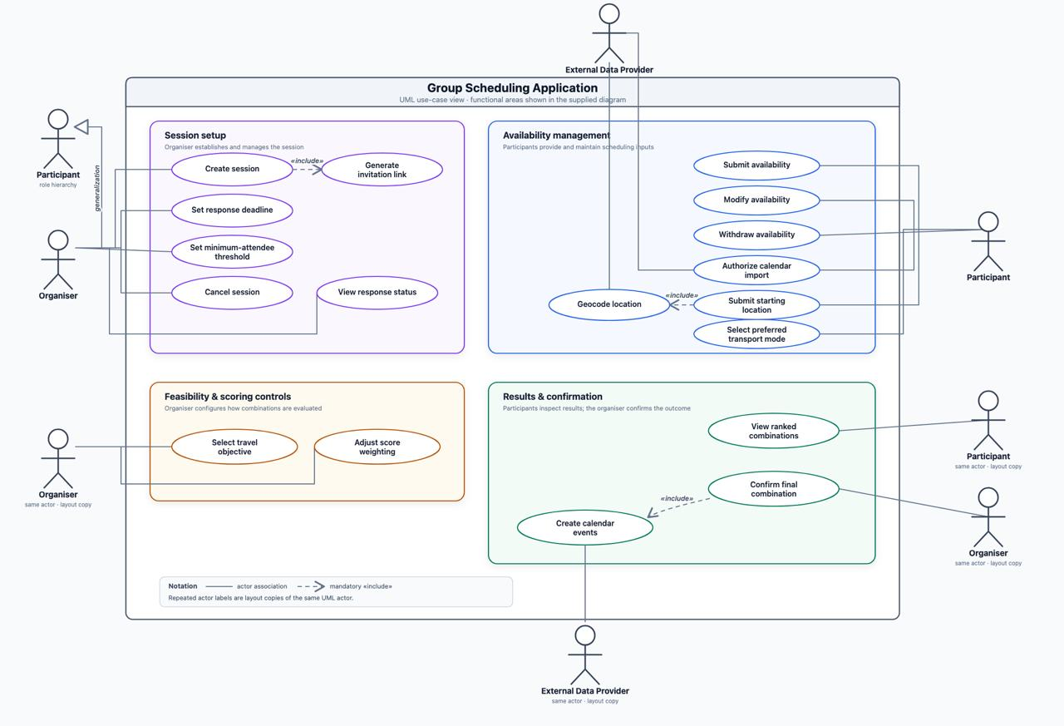
Figure 4 — Use case diagram, Group Scheduling Application.
The use-case descriptions (UC-01 to UC-12) appear as stimulus/response sequences in Sections 4.1.2, 4.2.2, 4.3.2, 4.4.2 and 4.5.2, alongside the functional requirements they exercise. UC-02 and UC-05 do not each correspond to a single bubble in Figure 4: UC-02 consolidates the diagram's separate "Set response deadline" and "Set minimum-attendee threshold" use cases (plus date/duration editing, which has no bubble of its own), and UC-05 covers joining a Session, a step the diagram omits before "Submit availability" begins.
B.2 Core data relationships
Entity A | Relationship | Entity B | Description
UserAccount | 1 : many | Participant | One User Account can hold a Participant record in many Sessions, but at most one per Session.
Session | 1 : many | Participant | One Organiser and invited Participants belong to a Session.
Participant | 1 : 0..1 current | AvailabilityRecord | A Participant has at most one current active response in a Session.
AvailabilityRecord | 1 : many | AvailabilityInterval | A response can contain several available or busy intervals.
ActivityType | 1 : many | Session | Each Session selects one supported Activity Type.
Venue | many : many | ActivityType | VenueActivity records which activities a Venue supports.
Session | 1 : many | CandidateTimeslot | Candidate Timeslots are generated inside the Session range.
Session | many : many | Venue | VenueShortlistEntry stores shortlisted Venues for a Session.
CandidateTimeslot | many : many | Participant | TimeslotAttendance stores each Participant’s attendance state.
CandidateTimeslot + Venue | forms | Combination | A Combination pairs one Timeslot with one shortlisted Venue.
Combination | 1 : many | TravelEstimate | Travel time is estimated for attending Participants.
Participant | 1 : 0..1 | CalendarConnection | Google Calendar connection is optional.
CalendarConnection | 1 : many | CalendarEvent | Only System-created Calendar events are tracked.

The class diagrams derived from this model are shown in Figures 1 and 2 (Section 2.2); an entity-relationship diagram is to be produced in the design phase.
B.3 Data model
The tables below describe the data the System needs and the main rules around it. They are written at requirements level and do not fix the final database design.
B.3.1 ActivityType
Data Item | Type | Description | Constraints | Related
ActivityTypeID | UUID | Unique ID for an activity type. | System-generated and unique. | FR-A1, FR-C3
ActivityCategory | String / Enum | General category, such as Sports. | From the supported category list. | FR-A1
ActivityTypeName | String | Specific activity, such as Football. | Belongs to an Activity Category. | FR-A1, FR-C3
IsActive | Boolean | Shows whether the activity is available for selection. | Default: TRUE. | FR-C3

B.3.2 Session
Data Item | Type | Description | Constraints | Related
SessionID | UUID | Unique ID for a Session. | System-generated and unique. | FR-A1, FR-A2
OrganiserParticipantID | UUID | Organiser who creates and manages the Session. | References the Organiser in the same Session. | FR-A1, FR-A3 to A5
ActivityTypeID | UUID | Activity selected for the Session. | References an active Activity Type. | FR-A1, FR-C3
DateRangeStart / End | DateTime | Earliest and latest allowed activity time. | Start is earlier than End. | FR-A1, FR-C1
Timezone | String | Timezone used for Session times. | Used consistently within the Session. | Section 6
DurationMinutes | Integer | Length of the activity. | 15 to 480 minutes. | FR-A1, FR-A1.1
ResponseDeadline | DateTime | Deadline for responses and changes. | Earlier than DateRangeStart. | FR-A3, FR-A3.1, FR-B5, FR-B6
MinimumAttendeeThreshold | Integer | Minimum attendance for feasibility. | Positive; default remains TBD. | FR-A4, FR-D1, TBD-2
TravelObjective | Enum | Organiser’s travel objective. | MIN_TOTAL or MIN_MAX_INDIVIDUAL. | FR-D6, FR-D7
AttendanceWeightPercent | Integer | Weight given to Attendance Score. | 0, 10, …, 100. | FR-D9, FR-D9.1
TravelWeightPercent | Integer | Weight given to Travel Score. | 100 − AttendanceWeightPercent. | FR-D9, FR-D9.1
SessionStatus | Enum | Current Session state. | ACTIVE, CONFIRMED, or CANCELLED. | FR-A5, FR-E4
InvitationToken | String | Token carried by the invitation link. | Unique, difficult to guess, and non-public Access Data. | FR-A2
ConfirmedCombinationID | UUID / Null | Final Combination selected by the Organiser. | Empty before confirmation; same Session and feasible afterwards. | FR-E4

Organiser-only actions are authorised by checking whether the signed-in User Account matches the Session's OrganiserParticipantID (TBD-11 resolved).
B.3.3 UserAccount
Data Item | Type | Description | Constraints | Related
UserAccountID | UUID | Unique ID for a person's persistent sign-in identity. | System-generated and unique. | FR-A1
GoogleAccountID | String | Stable identifier returned by Google Sign-In for this person. | Unique; never displayed to other users. | FR-A1, NFR-13
Email | String | Email address associated with the Google Account. | Unique; used only for sign-in, never shown to other Participants. | FR-A1, NFR-13
DisplayName | String | Name shown to the person while signed in; the default source for a Participant's DisplayName in a Session. | Supplied by Google Sign-In; may be overridden per Session (B.3.4 Participant). | FR-B7
CreatedAt | DateTime | When this User Account was first created. | Set once, on first sign-in; never updated. | FR-A1
B.3.4 Participant
Data Item | Type | Description | Constraints | Related
ParticipantID | UUID | Unique ID for a Participant in a Session. | System-generated and unique. | FR-B1 to B10
UserAccountID | UUID | Persistent identity of the person who owns this Participant record. | References a valid User Account; unique per (SessionID, UserAccountID) pair. | FR-A1 (resolves TBD-10)
SessionID | UUID | Session the Participant belongs to. | References a valid Session. | FR-B1, FR-B7
DisplayName | String | Name shown in response and attendance lists. | Distinguishes Participants in the Session. | FR-B7, FR-E3
Role | Enum | Role in the Session. | ORGANISER or PARTICIPANT. | FR-A1
ResponseStatus | Enum | Current response state. | NOT_SUBMITTED, SUBMITTED, or WITHDRAWN. | FR-B5 to B7

Participant identity is now established by the signed-in User Account (Section 2.5, C5); TBD-10 is resolved.
B.3.5 AvailabilityRecord
Data Item | Type | Description | Constraints | Related
AvailabilityRecordID | UUID | Unique ID for an availability submission. | System-generated and unique. | FR-B1
ParticipantID | UUID | Participant who owns the response. | References a valid Participant. | FR-B1
LocationInputType | Enum | Type of starting-location input. | ADDRESS or POSTAL_CODE. | FR-B2
LocationInput | String | Address or postal code used for routing. | Not shown to other Participants. | FR-B2, FR-B3, NFR-12, NFR-13
Latitude / Longitude | Decimal / Null | Coordinates returned by geocoding. | Present after valid geocoding; legal coordinate ranges. | FR-B3
GeocodeStatus | Enum | Result of geocoding. | PENDING, VALID, INVALID, or UNAVAILABLE. | FR-B3.1, NFR-3
TransportMode | Enum | Preferred transport mode. | WALK, DRIVE, or PUBLIC_TRANSPORT. | FR-B4, FR-D2
SubmissionSource | Enum | How availability was entered. | MANUAL or CALENDAR_ASSISTED. | FR-B1, FR-B8
RecordStatus | Enum | Whether the response is active. | ACTIVE or WITHDRAWN. | FR-B6, NFR-11
SubmittedAt / WithdrawnAt | DateTime / Null | Business timestamps for submission or withdrawal. | Submitted by deadline; withdrawal time set when relevant. | FR-B1, FR-B6

B.3.6 AvailabilityInterval
Data Item | Type | Description | Constraints | Related
AvailabilityIntervalID | UUID | Unique ID for one interval. | System-generated and unique. | FR-B1, FR-B8
AvailabilityRecordID | UUID | Availability Record containing the interval. | References a valid record. | FR-B1
StartDateTime / EndDateTime | DateTime | Start and end of the interval. | Inside Session range; Start is earlier than End. | FR-B1
IntervalType | Enum | Whether the interval is available or busy. | AVAILABLE or BUSY. | FR-B1, FR-B8
IntervalSource | Enum | Where the interval came from. | MANUAL or GOOGLE_CALENDAR. | FR-B1, FR-B8

Calendar-assisted entry uses free/busy information only; unrelated event content is not collected.
B.3.7 Venue
Data Item | Type | Description | Constraints | Related
VenueID | UUID | Unique ID for a Venue. | System-generated and unique. | FR-C3
VenueName | String | Public Venue name. | Non-empty. | FR-E1
VenueCategory | Enum | Venue category. | SPORTS_FACILITY, PARK, or MALL. | FR-C5
VenueAddress | String | Public Venue address. | Available for result display. | FR-E1
Latitude / Longitude | Decimal | Venue coordinates. | Legal coordinate ranges. | FR-C4, FR-D2, FR-E1
DataSource | String / Enum | Source of Venue information. | Documented and authorised source. | NFR-17
MinimumGroupSize | Integer / Null | Minimum group size where applicable. | Positive when provided. | FR-C6, FR-D4
OptimalGroupSize | Integer / Range / Null | Group size considered suitable. | Exact representation remains TBD. | FR-C6, TBD-4
AdvanceBookingLeadMinutes | Integer / Null | Minimum advance booking time. | Zero or more where applicable. | FR-C6, FR-D5

The data source for Mall Venues remains TBD (TBD-5).
B.3.8 VenueActivity
Data Item | Type | Description | Constraints | Related
VenueID | UUID | Venue in the mapping. | References a valid Venue. | FR-C3
ActivityTypeID | UUID | Supported activity in the mapping. | References a valid Activity Type. | FR-C3
SupportStatus | Enum | Whether the activity is currently supported. | SUPPORTED or UNAVAILABLE. | FR-C3
SourceReference | String / Null | Reference supporting the mapping. | Included where the source supplies one. | NFR-17

The VenueID and ActivityTypeID pair is unique.
B.3.9 CandidateTimeslot
Data Item | Type | Description | Constraints | Related
CandidateTimeslotID | UUID | Unique ID for a generated Timeslot. | System-generated and unique. | FR-C1
SessionID | UUID | Session that owns the Timeslot. | References a valid Session. | FR-C1
StartDateTime / EndDateTime | DateTime | Start and end of the candidate period. | Within Session range; duration matches Session duration. | FR-C1
GenerationStatus | Enum | Current generation result. | GENERATED or INVALIDATED. | FR-C1
AvailableCount | Integer | Number of Participants available. | Derived from active responses. | FR-C2, FR-E3

The interval between successive Candidate Timeslot start times is not stated (TBD-13).
B.3.10 TimeslotAttendance
Data Item | Type | Description | Constraints | Related
CandidateTimeslotID | UUID | Timeslot being checked. | References a Timeslot in the same Session. | FR-C2
ParticipantID | UUID | Participant being checked. | References a Participant in the same Session. | FR-C2
AttendanceStatus | Enum | Attendance result for the Timeslot. | AVAILABLE, UNAVAILABLE, NO_RESPONSE, or WITHDRAWN. | FR-C2, FR-E3
Source | Enum | Data used for the result. | MANUAL, CALENDAR, or NONE. | FR-B1, FR-B8
ReasonCode | String / Null | Short reason where useful. | Does not expose private Calendar details. | NFR-13

NO_RESPONSE and WITHDRAWN remain separate from UNAVAILABLE.
B.3.11 VenueShortlistEntry
Data Item | Type | Description | Constraints | Related
SessionID | UUID | Session using the shortlist. | References a valid Session. | FR-C4
VenueID | UUID | Venue retained in the shortlist. | Supports the selected Activity Type. | FR-C3, FR-C4
CentroidLatitude / Longitude | Decimal | Centroid used for shortlisting. | Derived from valid active Participant locations. | FR-C4
StraightLineDistanceKm | Decimal | Distance from centroid to Venue. | Used for shortlisting, not final travel scoring. | FR-C4
ShortlistRank | Integer | Venue position in the shortlist. | Positive; unique within the Session. | FR-C4
ShortlistStatus | Enum | Whether the entry is current. | CURRENT or INVALIDATED. | FR-C4

Shortlist size N is TBD (TBD-2). The shortlist is calculated each time the Organiser runs Generate Recommendations (UC-09); entries from earlier runs are marked INVALIDATED.
B.3.12 Combination
Data Item | Type | Description | Constraints | Related
CombinationID | UUID | Unique ID for a Timeslot-Venue pair. | System-generated and unique. | FR-D1
SessionID | UUID | Session that owns the Combination. | References a valid Session. | FR-D1
CandidateTimeslotID | UUID | Candidate time in the pair. | Belongs to the same Session. | FR-D1
VenueID | UUID | Shortlisted Venue in the pair. | Current shortlist entry for the same Session. | FR-D1
AttendeeCount | Integer | Number of available Participants. | Derived from TimeslotAttendance. | FR-D1, FR-D4
FeasibilityStatus | Enum | Whether the pair can be selected. | FEASIBLE, EXCLUDED, or DATA_UNAVAILABLE. | FR-D1 to D5
ExclusionReason | Enum / Null | Reason a pair is excluded. | Below threshold, journey limit, group size, or booking lead time. | FR-D1, FR-D3 to D5
AttendanceScore | Decimal / Null | Attendance component of ranking. | Derived; exact normalisation remains open. | FR-D8
TravelScore | Decimal / Null | Travel component of ranking. | Derived; exact normalisation remains open. | FR-D7
CombinedScore | Decimal / Null | Weighted final score. | Uses Session weights. | FR-D9
Rank | Integer / Null | Position among feasible Combinations. | Positive; tie-break rule remains open. | FR-D10

DATA_UNAVAILABLE means required external data is missing; it is not the same as a normal feasibility exclusion.
B.3.13 TravelEstimate
Data Item | Type | Description | Constraints | Related
TravelEstimateID | UUID | Unique ID for one route estimate. | System-generated and unique. | FR-D2
CombinationID | UUID | Combination being evaluated. | References a valid Combination. | FR-D2
ParticipantID | UUID | Attending Participant for the route. | Available for the related Timeslot. | FR-D2
TransportMode | Enum | Mode used for routing. | Matches the current Participant preference. | FR-B4, FR-D2
TravelDurationMinutes | Integer / Null | Estimated one-way travel time. | Zero or more when routing succeeds. | FR-D2, FR-E2
RoutingStatus | Enum | Outcome of the routing request. | AVAILABLE, UNAVAILABLE, or ERROR. | FR-D2, NFR-3
JourneyLimitExceeded | Boolean / Null | Whether travel is over the allowed maximum. | Set when duration and limit are available. | FR-D3

B.3.14 CalendarConnection
Data Item | Type | Description | Constraints | Related
CalendarConnectionID | UUID | Unique ID for a Calendar connection. | System-generated and unique. | FR-B8
ParticipantID | UUID | Participant who owns the connection. | References a valid Participant. | FR-B8
Provider | Enum | Calendar provider. | GOOGLE for the current integration. | NFR-7
GrantedScopes | String / Set | OAuth permissions granted to the System. | Free/busy read plus minimum extra permission for System-created event create and delete. | FR-B8 to B10, FR-E6, NFR-14
CredentialReference | Secure Reference / Null | Backend reference to OAuth credentials. | Backend access only; absent after disconnection. | NFR-9, NFR-12
ConnectionStatus | Enum | Current connection state. | CONNECTED, DISCONNECTED, DECLINED, EXPIRED, or ERROR. | FR-B8, FR-B8.1

Manual availability stays available without Google Calendar.
B.3.15 CalendarEvent
Data Item | Type | Description | Constraints | Related
CalendarEventID | UUID | Unique ID for a System-created Calendar event. | System-generated and unique. | FR-B9, FR-E6
CalendarConnectionID | UUID | Calendar connection used for the event. | References a connected account. | FR-B9, FR-E6
SessionID | UUID | Related Session. | References a valid Session. | FR-B9, FR-E6
CombinationID | UUID | Timeslot-Venue pair represented by the event. | References a Combination in the same Session. | FR-B9, FR-E6
ProviderEventID | String | Provider’s event identifier. | Used only for events created by this System. | FR-B9, FR-B10, FR-E6
EventType | Enum | Purpose of the event. | TENTATIVE_HOLD or CONFIRMED_EVENT. | FR-B9, FR-E6
EventStatus | Enum | Current event state. | ACTIVE, DELETED, or ERROR. | FR-B10, FR-E6

The System does not edit or delete unrelated Calendar events.
B.4 System configuration and derived data
These values support the requirements but do not prescribe how they are stored.
Configuration Item | Meaning | Current Value / Status | Related
MaximumJourneyTimeMinutes | Maximum accepted individual journey time. | TBD | FR-D3, TBD-1
DefaultMinimumAttendeeThreshold | Fallback attendance threshold. | TBD | FR-A4, TBD-2
VenueShortlistN | Number of Venues retained. | TBD | FR-C4, TBD-2
RoutingProvider | Routing source, especially for public transport. | TBD | FR-D2, TBD-3
CandidateTimeslotStepMinutes | Interval between generated start times. | Not specified | FR-C1, TBD-13
WeightIncrementPercent | Allowed scoring-weight step. | 10% | FR-D9.1

Derived Item | Summary Rule | Related
Centroid | Calculated from valid active Participant coordinates; used only for shortlisting. | FR-C4
AvailableCount | Count of Participants marked AVAILABLE for a Candidate Timeslot. | FR-C2
FeasibilityStatus | Checks threshold, journey limit, group size and booking lead time when data is available. | FR-D1 to D5
Travel objective value | Uses total travel time or maximum individual travel time, based on Organiser choice. | FR-D6, FR-D7
CombinedScore | AttendanceWeight × AttendanceScore + TravelWeight × TravelScore. | FR-D8, FR-D9
Rank | Orders feasible Combinations by CombinedScore; tie-break rule is TBD. | FR-D10, TBD-9

Appendix C: To Be Determined List
Every unresolved point in this SRS is listed below for tracking to closure. Items TBD-1 to TBD-9 are the Open Questions requiring a client decision; items TBD-10 to TBD-15 are gaps or internal inconsistencies to be closed by the team, the client, or in design. No item may remain open when the affected requirement is implemented.
Ref. | Item | Affected requirement | Owner
TBD-1 | What is the maximum individual-journey-time threshold used to exclude a Combination? | FR-D3 | Client
TBD-2 | What is the default Minimum-Attendee Threshold when the Organiser does not set one explicitly, and what fixed value of N (number of Venues shortlisted nearest to the Participant centroid) should the System use? | FR-A4, FR-C4 | Client
TBD-3 | Does OneMap’s own routing API natively cover public-transport multimodal journeys, or is LTA DataMall still required as a separate source for those legs? | FR-D2, Section 3.3 | Client / team
TBD-4 | What defines a Venue’s “optimal” group size numerically, and how should attendance moving away from that optimum affect the attendance score? | FR-C6, FR-D4, FR-D8 | Client
TBD-5 | Where does Mall venue data come from, given there is no dedicated data.gov.sg dataset for malls? | FR-C3, FR-C5 | Client / team
TBD-6 | Should a returning Participant’s profile (location, transport preference) persist across Sessions, or is every Session’s submission independent? — RESOLVED: the Google Account sign-in persists a person’s identity across Sessions (Section 2.5, C5); starting location and transport mode are submitted independently for each Session on that Session’s Availability Record (FR-B2, FR-B4). | Section 4.2 | Resolved
TBD-7 | What is the maximum supported number of concurrent Participants per Session? | Section 4.1, NFR-1 | Client
TBD-8 | Where should the production database be hosted, and does PDPA data residency restrict this to Singapore-based infrastructure? | NFR-9, NFR-10, Section 2.4 | Client
TBD-9 | When two Combinations tie exactly on Combined Score, what tiebreaking rule should apply? | FR-D10 | Client
TBD-10 | The invitee identification process needs clarification so submitted and non-submitted invitees can be distinguished. — RESOLVED: identity is established by the Google Account sign-in (Section 2.5, C5); no separate identifier is needed. | FR-B7 | Resolved
TBD-11 | The mechanism authorising Organiser-only actions is a design decision not yet made. The SRS identifies which actions are restricted. — RESOLVED: authorisation checks whether the signed-in User Account matches the Session's OrganiserParticipantID (Section 2.5, C5). | FR-A3 to A5, FR-D6, FR-D9, FR-E4 | Resolved
TBD-12 | Inconsistency: NFR-14 requires free/busy-only OAuth scope, while FR-B9, FR-B10 and FR-E6 require event creation and deletion. NFR-14 must be reworded to free/busy read plus the minimum extra permission for events created by this System. — RESOLVED: NFR-14 reworded in v2.1 to free/busy read plus the minimum scope to create and delete System-created events. | FR-B8 to B10, FR-E6, NFR-14 | Resolved
TBD-13 | The interval between successive Candidate Timeslot start times is not specified. | FR-C1 | Team
TBD-14 | When the first centroid and Venue shortlist are calculated, and when they are recalculated, for example after the first valid location, after the deadline, or after relevant location changes. — RESOLVED: calculated each time the Organiser runs Generate Recommendations (UC-09) and recalculated on every later run (FR-C4). | FR-C4 | Resolved
TBD-15 | The exact calculation and normalisation of the Attendance Score and Travel Score are not specified. | FR-D7, FR-D8 | Team

Appendix D: Data Dictionary
Term | Brief Description | Key Attributes | Relationships
Session | A proposed group activity. It stores the activity, possible date range, duration, response deadline, minimum attendance, travel objective, scoring weights and current status. | Activity type; date range; timezone; duration; response deadline; minimum attendance; travel objective; scoring weights; status. | Each Session has one Organiser, can include multiple Participants, can generate multiple Candidate Timeslots and can have one Final Selection.
Organiser | The Participant who creates and manages a Session, shares the invitation link, reviews the suggestions and confirms or cancels the Session. | Participant reference; organiser role; Session management access. | An Organiser can create and manage multiple Sessions. The Organiser shares invitation links, reviews ranked Combinations and confirms or cancels each Session.
Participant | A person invited to a Session who can submit, update or withdraw availability, starting location and transport preference. | Role; response status; starting location; transport mode; Calendar connection status. | A Session can include multiple Participants. For a given Session, each Participant has no more than one current Availability Record.
Activity Type | The selected activity, such as Football. It is used to identify Venues that support the Session activity. | Activity name; activity category. | Each Session selects one Activity Type. A Venue can support multiple Activity Types, and an Activity Type can be supported by multiple Venues through Venue Activity records.
Session Duration | The planned length of the activity. It is used with a Candidate Timeslot start time to calculate its end time. | Length; time unit. | Each Session has one planned duration. The duration is added to a Candidate Timeslot's start time to obtain its end time.
Response Deadline | The final date and time for Participants to submit, edit or withdraw their responses before suggestions are prepared. | Deadline date; deadline time; Session timezone. | Each Session has one Response Deadline, which applies to all Participants invited to that Session.
Minimum Attendee Threshold | The smallest number of available Participants needed for an option to remain feasible. The default value is still to be confirmed. | Minimum Participant count; default value = TBD. | Each Session has one Minimum Attendee Threshold. Candidate Timeslots below the threshold are not feasible.
Travel Objective | The Organiser's choice to minimise either the group's total travel time or the longest individual journey. | Option: total group travel time or longest individual journey. | Each Session uses one Travel Objective to determine the Travel Score for its Combinations.
Session Status | The current Session state: active while planning, confirmed after the final choice, or cancelled. | Active; confirmed; cancelled. | Each Session has one current status. A Final Selection changes it to confirmed, while cancellation changes it to cancelled.
Invitation Token | A unique, difficult-to-guess value in the Session invitation link. It is non-public Access Data and is kept out of public pages and ordinary logs. | Token value; linked Session; classification = non-public Access Data. | Each Invitation Token belongs to one Session. The number of tokens allowed for a Session is not specified; the token is used in the invitation link and kept out of public pages and ordinary logs.
Response Status | Shows whether an invited Participant has not submitted, has submitted, or has withdrawn a response. Each invitee is identified by their signed-in User Account. | Not submitted; submitted; withdrawn. | Each Participant has one Response Status within a Session. It is reflected in the current Availability Record; each invitee is identified by their signed-in User Account.
Availability Record | A Participant's current response for one Session, including starting location, transport mode, availability intervals and whether the response is active or withdrawn. | Response status; starting location; transport mode; submission source; active or withdrawn state. | For a given Session, each Participant has at most one current Availability Record. An Availability Record contains one or more Availability Intervals.
Starting Location | An address or postal code entered by a Participant and converted to coordinates for calculations. It is private and is not shown to other Participants. | Address or postal code; latitude; longitude. | Each Availability Record contains one Starting Location. The location is used by Travel Estimates and is not shown to other Participants.
Location Validation Status | Shows whether a starting location is pending, valid, invalid or unavailable. Invalid input is kept separate from a geocoding service failure. | Pending; valid; invalid; unavailable. | Each Starting Location has one current validation status. Invalid input is kept separate from a geocoding service failure.
Transport Mode | The Participant's selected way of travelling: walking, driving or public transport. It is used for routing-based travel estimates. | Walking; driving; public transport. | Each Availability Record contains one selected Transport Mode, which is used when calculating Travel Estimates.
Availability Interval | A period during which a Participant is available or busy. It can be entered manually or obtained from Google Calendar free/busy data. | Start date and time; end date and time; available or busy state; source. | An Availability Record can contain multiple Availability Intervals. An interval may be entered manually or obtained from Calendar Free Busy Data.
Calendar Connection | An optional Google Calendar authorization linked to a Participant. Its permissions are limited to free/busy read plus creating and deleting System-created events (NFR-14). | Provider; connection status; free or busy permission; System-event permission. | A Participant may have an optional Calendar Connection. A connection can provide multiple Calendar Free Busy Data records and support multiple Calendar Events.
Calendar Free Busy Data | Busy or free time read from an existing Calendar. Event titles, descriptions, attendees and unrelated event content are not collected. | Start date and time; end date and time; free or busy state; retrieval status. | A Calendar Connection can provide multiple Calendar Free Busy Data records. These records may produce Availability Intervals; titles, descriptions, attendees and unrelated content are not collected.
Candidate Timeslot | A possible Session time generated inside the date range using the Session Duration. The interval between possible start times is still to be confirmed. | Start date and time; end date and time; attendance count; feasibility status. | A Session can generate multiple Candidate Timeslots. Each timeslot can have multiple Timeslot Attendance records and can be paired with multiple Venues through Combinations. The interval between possible starts is still to be confirmed.
Timeslot Attendance | The calculated state of one Participant for one Candidate Timeslot: available, unavailable, no response or withdrawn. | Participant; Candidate Timeslot; available, unavailable, no response or withdrawn. | Each Timeslot Attendance record links one Participant with one Candidate Timeslot. Available records contribute to the Attendance Count.
Attendance Count | The number of Participants available for a Candidate Timeslot. It is used for feasibility checking and scoring. | Calculated number of available Participants. | Each Candidate Timeslot has one calculated Attendance Count, based on its Timeslot Attendance records and used for feasibility and scoring.
Venue | A sports facility, park or mall that may host the activity. It includes a public name, address, coordinates and source; the Mall Venue source is still to be confirmed. | Public name; category; address; coordinates; capacity; advance-booking window; data source. | A Venue can support multiple Activity Types through Venue Activity records and can appear in the shortlists of multiple Sessions. The Mall Venue source is still to be confirmed.
Venue Activity | A link showing that a Venue supports an Activity Type and whether that support has been verified. | Venue; Activity Type; verification status. | Each Venue Activity record links one Venue with one supported Activity Type. A Venue and an Activity Type can each appear in multiple such records.
Venue Capacity | A Venue's minimum or optimal group-size information. How the optimal value affects scoring still needs clarification. | Minimum group size; optimal group size; scoring effect = TBD. | A Venue may have Venue Capacity information. It is checked when evaluating the feasibility of a Combination.
Advance Booking Window | A Venue condition showing how far in advance it can be booked. A Candidate Timeslot inside the restricted period is excluded. | Restricted advance-booking period; booking eligibility. | A Venue may have an Advance Booking Window. Candidate Timeslots inside the restricted period are excluded.
Venue Shortlist | The nearest eligible Venues retained for one Session. It is calculated each time the Organiser runs Generate Recommendations; its size still needs clarification. | Eligible Venues; shortlist size = TBD; calculation state. | A Session may have a Venue Shortlist containing multiple Venues. It is calculated each time the Organiser runs Generate Recommendations.
Geographic Centroid | The centre point calculated from valid Participant coordinates for Venue shortlisting. Individual private locations are not displayed. | Latitude; longitude; calculation status. | A Session may have one Geographic Centroid. It is derived from valid Participant coordinates and used for Venue shortlisting; private locations are not displayed.
Straight Line Distance | The direct distance from the Geographic Centroid to a Venue. It is used only for shortlisting, while final travel calculations use routing data. | Distance value; distance unit; centroid and Venue endpoints. | Each shortlisted Session and Venue pair has one Straight Line Distance. It orders the shortlist, while final travel calculations use routing data instead.
Combination | One Candidate Timeslot paired with one shortlisted Venue. Each Combination is checked, scored and ranked before the Organiser chooses an option. | Candidate Timeslot; shortlisted Venue; feasibility status; exclusion reason; scores; rank. | A Session can have multiple Combinations, each pairing one Candidate Timeslot with one shortlisted Venue. One feasible Combination may become the Final Selection.
Feasibility Status | Shows whether a Combination is pending, feasible, excluded or missing required external data. Data unavailable is different from normal exclusion. | Pending; feasible; excluded; missing required external data. | Each Combination has one current Feasibility Status. Data unavailable is different from normal exclusion.
Exclusion Reason | Explains why an option is removed, such as low attendance, excessive journey time, an unmet Venue group size or an advance-booking restriction. | Low attendance; excessive journey time; unmet Venue group size; advance-booking restriction. | An excluded Combination has an Exclusion Reason, while a non-excluded Combination may have none.
Travel Estimate | A routing-based one-way journey time from an attending Participant's Starting Location to a Venue using the selected Transport Mode. The public-transport provider is still to be confirmed. | Participant; Venue; transport mode; one-way journey time; provider and service status. | A Combination can have multiple Travel Estimates, normally one for each attending Participant. The public-transport provider is still to be confirmed.
Maximum Journey Time Threshold | The longest journey allowed for an attending Participant. A Combination is excluded when the threshold is exceeded; its value is still to be confirmed. | Maximum duration; time unit; value = TBD. | The Maximum Journey Time Threshold is applied to Travel Estimates when each Combination is checked. Whether it is stored for each Session or as System configuration is not yet specified.
Score Components | Attendance Score represents expected attendance and Travel Score represents the selected travel objective. Their exact calculation and normalisation are not yet specified. | Attendance Score; Travel Score; calculation and normalisation = TBD. | Each Combination has Attendance and Travel Score Components. They use the Attendance Count, Travel Objective and Travel Estimates.
Scoring Weights | The percentages chosen by the Organiser for attendance and travel. Attendance changes in 10 percent steps and the two weights total 100 percent. | Attendance weight; travel weight; total = 100 percent; attendance changes in 10 percent steps. | Each Session has one pair of Scoring Weights, which is applied to the Score Components of every feasible Combination.
Combined Score and Rank | The weighted result used to order feasible Combinations. A higher-ranked option is shown earlier; the tie-break rule for equal scores is still to be confirmed. | Combined score; rank; equal-score tie-break = TBD. | Each Combination has a Combined Score and Rank derived from its Score Components and the Session's Scoring Weights.
Final Selection | The feasible Candidate Timeslot and Venue confirmed by the Organiser and stored as the Session's final choice. | Selected Candidate Timeslot; selected Venue; confirmation status. | A Session may have one Final Selection. It references one feasible Combination and may create Calendar Events.
Calendar Event | A tentative hold or confirmed Session event created through a Calendar Connection. Its provider reference allows the System to update or delete only events that it created. | Tentative or confirmed type; event status; provider reference; Session reference. | A Calendar Connection can contain multiple System-created Calendar Events, and a Session may create events for multiple connected Participants. The provider reference allows the System to update or delete only events that it created.
Session Date Range | The earliest and latest date and time in which the activity may take place. Candidate Timeslots are generated only within this range. | Earliest date and time; latest date and time. | Each Session has one Session Date Range, and all of its Candidate Timeslots are generated within that range.
Session Timezone | The timezone used to interpret and display all Session deadlines, availability intervals, Candidate Timeslots and Calendar Events consistently. | Timezone identifier. | Each Session uses one timezone for its deadlines, Availability Intervals, Candidate Timeslots and Calendar Events.
Activity Category | A general grouping such as Sports. It helps organise the supported Activity Types without replacing the specific activity selected for a Session. | Category name, such as Sports. | An Activity Category can contain multiple Activity Types. A Session still selects one specific Activity Type.
Participant Role | Shows whether a person is the Organiser or a Participant. Each Session has one Organiser, while other invitees take the Participant role. | Organiser; Participant. | Each person has one Participant Role within a Session. Every Session has one Organiser, while the other invitees take the Participant role.
Submission Source | Shows whether an Availability Record was prepared manually or with help from Google Calendar. | Manual; Google Calendar assisted. | Each Availability Record has one Submission Source, showing whether the response was prepared manually or with Google Calendar assistance.
Venue Category | The general type of Venue, such as a sports facility, park or mall. It helps the System organise Venue choices. | Sports facility; park; mall. | A Venue Category can group multiple Venues, while each Venue is assigned to one category.
Venue Data Source | The documented source from which Venue information is obtained. Only authorised sources are used, and the Mall Venue source is still to be confirmed. | Source name; authorisation status; Mall Venue source = TBD. | A Venue Data Source can supply information for multiple Venues. Each Venue records its source, and only authorised sources are used.
Shortlist Position | The nearest-first position assigned to a Venue after straight-line distances are compared for one Session. | Nearest-first positive position. | Each Session and Venue shortlist entry has one Shortlist Position derived from its Straight Line Distance.
Combination Status | Shows whether a Timeslot-Venue Combination is still a candidate, has been excluded, or has become the confirmed choice. | Candidate; excluded; confirmed. | Each Combination has one current status. A confirmed Combination is referenced by the Final Selection.
External Service Status | Shows whether geocoding, routing, Venue or Calendar data was received successfully, is unavailable, or returned an error. | Service type; success; unavailable; error. | Each geocoding, routing, Venue or Calendar result has one External Service Status. Many results may be produced over time, and unavailable data is not treated as normal exclusion.
User Account | A sign-in identity used to recognise a returning person and link their participation across Sessions. | Stable user ID; email address; display name; sign-in provider (Google). | A User Account can link to Participant records in multiple Sessions, but to at most one Participant record in each Session. A Calendar Connection is optional and needs separate authorisation.
Appendix E: System Architecture
This appendix records the system architecture chosen in the design phase. It describes how the design satisfies the constraints in Section 2.5 and the non-functional requirements in Section 5; it adds no new requirement. Class names follow the unified design class diagram (R10), and the design issues follow Bruegge and Dutoit (R9).
E.1 Architecture style and rationale
The System is a three-tier client-server application with a layered backend (Figure 5).
• Three tiers. A browser client, a backend application server and a SQL database. The database is reachable only from the backend (NFR-9), and no client code calls an external API (Section 2.1).
• Layered backend. Boundary, control, entity and adapter layers mirror the «boundary», «control» and «entity» stereotypes in the class diagrams (Figures 1 and 2). Each layer calls only the layer beneath it, which keeps cohesion high and coupling low.
• Adapter pattern for providers. Each external provider client implements a provider interface. The Recommender depends only on the interface, so a provider can be replaced without changing Section 4.4 code (C6, NFR-15).
• Repository pattern for persistence. Repositories isolate SQL access, so the database can be moved to another SQL-compliant engine without changing the Feasibility and Scoring engine (C7, NFR-16).
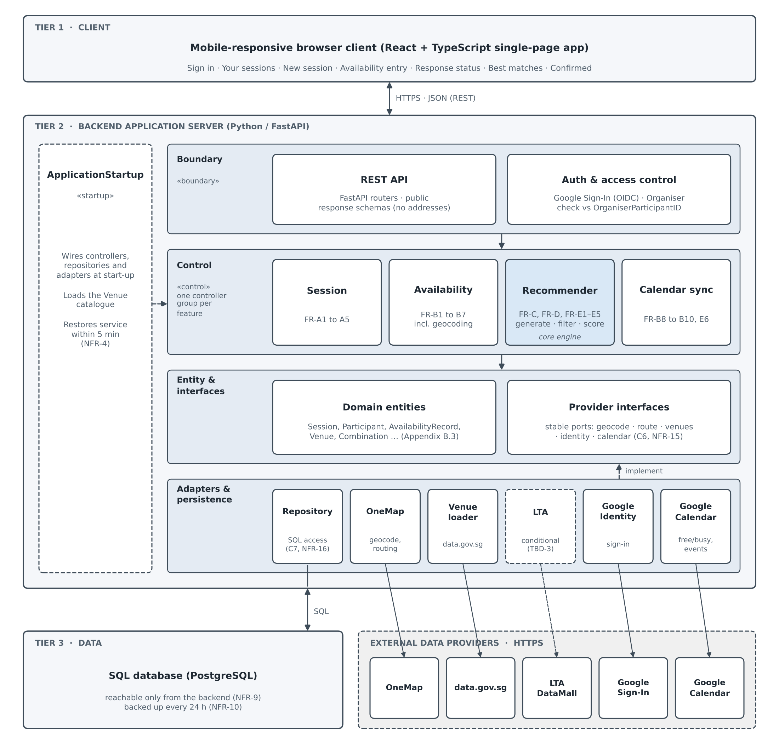
Figure 5 — System architecture: three tiers with a layered backend.
E.2 Backend layers
Table E-1 lists the components in each backend layer and the requirements each serves. The control layer has one controller group per feature module; the design classes in each group are those of the class diagram (R10).
Layer | Components | Serves
Boundary | REST API: FastAPI routers that return public response schemas rather than raw entities.  Authentication and access control (AuthenticationController, AuthorizationService): Google Sign-In (OpenID Connect) establishes identity, and Organiser-only actions are permitted only when the signed-in User Account matches the Session’s OrganiserParticipantID. | C5, NFR-13, Section 5.3
Control — Session | SessionController. | FR-A1 to FR-A5
Control — Availability | ParticipantController and AvailabilityController; geocoding of starting locations through TravelController.geocodeLocation(). | FR-B1 to FR-B7, FR-B8.1
Control — Recommender (core engine) | CandidateGenerationController, RecommendationController, TravelController and FinalPlanController: Candidate Timeslot generation, Venue shortlisting, feasibility filtering, scoring, ranking and confirmation. | FR-C1 to FR-C6, FR-D1 to FR-D10, FR-E1 to FR-E5
Control — Calendar sync | CalendarController: free/busy import, Tentative Hold Events and confirmed events. | FR-B8, FR-B9, FR-B9.1, FR-B10, FR-E6
Entity and interfaces | The domain entities of Appendix B.3 (Session, Participant, AvailabilityRecord, Venue, Combination and others), and the provider interfaces on which the controllers depend. | Appendix B.3, C6
Adapters and persistence | Repositories over the SQLModel entities and database session.  One adapter per external provider: OneMap, a data.gov.sg Venue loader, Google Identity, Google Calendar, and LTA DataMall only if TBD-3 requires it. | C6, C7, NFR-15, NFR-16
Table E-1 — Backend layers, components and the requirements they serve.
Start-up. ApplicationStartup («startup») creates the application, wires the controllers, repositories and adapters together, initialises the database and loads the Venue catalogue when the System starts. It is therefore the component on which the 5-minute restart target in NFR-4 depends.
E.3 Key design decisions
The following decisions address the system design issues in Bruegge and Dutoit, Section 7.4 (R9).
• Persistent data. Every entity in Appendix B.3 is stored in the SQL database, including the derived Combination and TravelEstimate records. OAuth credentials are stored by reference only (Section 5.5).
• Access control. Two layers. Identity comes from Google Sign-In; role (Organiser or Participant) comes from the Participant record for the Session in question. The API never returns a Starting Location to anyone other than its owner (NFR-13).
• Global control flow. Event-driven. Candidate generation and scoring run when the Organiser requests them (UC-09), not on a schedule (Section 3.4).
• Boundary conditions. Start-up is handled by ApplicationStartup. Any external failure is recorded as an explicit UNAVAILABLE or ERROR status and kept distinct from invalid user input and from normal feasibility exclusion (NFR-3).
Performance. The Recommender prunes Venues by straight-line distance to the N nearest the Geographic Centroid before it makes any routing call (C8, FR-C4). This bounds routing to one call per available Participant per shortlisted Venue, which keeps external call volume within NFR-2 and the scoring step within the 5-second target in NFR-1.
E.4 Open items that affect the design
• TBD-3. Whether the LTA DataMall adapter is needed at all.
• TBD-8. The hosting region, which PDPA data residency may restrict to Singapore.
• Calendar scope. NFR-14 (reworded in v2.1, closing TBD-12) requires the narrowest Google scope that lets the System write its own events. The Lab 3 report (R12) notes that Google’s narrowest such scope applies to a secondary calendar the application creates, so the adapter may need to write holds and confirmed events to a dedicated calendar.
Each of these sits behind a provider interface or in deployment configuration, so none of them requires rework of the core engine.

Source: http://www.frontiernet.net/~kwiegers/process_assets/srs_template.doc

